#### *W3.Safari.References*

***Ctrl+Click the following links to go to their place in this document***

* [***Requirements Determination***](#_Requirements_Determination)
* [***Interviews (under the Requirements Elicitation in Practice section)***](#_Interviews_(under_the)
* [***Joint Application Development******(under the Requirements Elicitation in Practice section)***](#_Joint_Application_Development)
* [***Questionnaires******(under the Requirements Elicitation in Practice section)***](#_Questionnaires_(under_the)
* [***Sampling***](#_Sampling)
* [***Estimating Sample Size***](#_Estimating_Sample_Size)
* [***Document Analysis******(under the Requirements Elicitation in Practice section)***](#_Document_Analysis_(under)
* [***Observation******(under the Requirements Elicitation in Practice section)***](#_Observation_(under_the)
* [***Selecting the Appropriate Techniques (under the Requirements Elicitation in Practice section)***](#_Selecting_the_appropriate)
* [***Requirements Analysis Strategies***](#_Requirements_Analysis_Strategies)

## Requirements Determination

[https://learning.oreilly.com/library/view/System+Analysis+and+Design,+Fifth+Edition/9781118057629/11\_chap03.html#chap03](https://learning.oreilly.com/library/view/System+Analysis+and+Design,+Fifth+Edition/9781118057629/11_chap03.html" \l "chap03)

*Requirements determination* is performed to transform the system request's high-level statement of business requirements into a more detailed, precise list of what the new system must do to provide the needed value to the business. This detailed list of requirements is supported, confirmed, and clarified by the other activities of the analysis phase: creating use cases, building process models, and building a data model. We first explain what a requirement is and discuss the process of creating a requirements definition statement.

### What Is a Requirement?

A *requirement* is simply a statement of what the system must do or what characteristics it needs to have. During a systems development project, requirements will be created that describe what the business needs *(business requirements)*; what the users need to do *(user requirements*); what the software should do *(functional requirements)*; characteristics the system should have*(nonfunctional requirements)*; and how the system should be built *(system requirements)*. Although this list of requirement categories may seem intimidating at first, the categories merely reflect the purpose of the requirements and the stage in the SDLC in which they are defined.

We have already discussed the creation of the systems request in the planning phase of the SDLC. In the system request, there are statements that describe the reasons for proposing the systems development project. These statements reflect the business requirements that this system, if built, will fulfill. These business requirements help define the overall goals of the system and help clarify the contributions it will make to the organization's success. Examples of business requirements include: “Increase market share”; “Shorten order processing time”; “Reduce customer service costs”; “Lower inventory spoilage”; “Improve responsiveness to customer service requests”; and “Provide account access to mobile customers.” When the systems development project is complete, success will be measured by evaluating whether the stated business requirements have actually been achieved; therefore, they provide the overall direction for the project.

During the analysis phase, requirements are written from the perspective of the business, and they focus on *what* the system needs to do in order to satisfy business user needs. A good starting place is to concentrate on what the user actually needs to accomplish with the system in order to fulfill a needed job or task. These user requirements describe tasks that the users perform as an integral part of the business' operations, such as: “Schedule a client appointment”; “Place a new customer order”; “Re-order inventory”; “Determine available credit”; and “Look up account balances.” Use cases (discussed in [Chapter 4](http://proquestcombo.safaribooksonline.com.ezproxy.umuc.edu/9781118057629/chapter_4_use_case_analysis#chap04)) are tools used to clarify the steps involved in performing these user tasks. By understanding what the user needs to do in terms of tasks to perform, the analyst can then determine ways in which the new system can support the users' needs.

Determining ways in which the new system can support user needs leads to statements of the system's functional requirements. A functional requirement relates directly to a process the system has to perform as a part of supporting a user task and/or information it needs to provide as the user is performing a task. The International Institute of Business Analysis (IIBA) defines functional requirements as “the product capabilities, or things that a product must do for its users.”[3](http://proquestcombo.safaribooksonline.com.ezproxy.umuc.edu/9781118057629/navPoint-48#fn.003_11_chap03) Functional requirements begin to define how the system will support the user in completing a task. For example, assume the user requirement is “Schedule a client appointment.” The functional requirements associated with that task include: “Determine client availability,” “Find available openings matching client availability,” “Select desired appointment,” “Record appointment,” and “Confirm appointment.” Notice how these functional requirements expand upon the user's task to describe capabilities and functions that the system will need to include, allowing the user to complete the task.

As the analyst works with the business users of the system to discover user and functional requirements, the user may reveal processes that will be needed or information that will be needed. For example, as shown in [Figure 3-1](http://proquestcombo.safaribooksonline.com.ezproxy.umuc.edu/9781118057629/navPoint-39#fig3-1), the user may state “The system must retain customer order history for three years” (an information need). The analyst should probe for the reasoning behind this statement, such as “The system should allow registered customers to review their own order history for the past three years” (a process need). Similarly, the user may state “The system should check incoming customer orders for inventory availability” (a process need). An alert analyst will recognize the related information need, “The system should maintain real-time inventory levels at all warehouses.” All of these requirements are necessary to fully understand the system that is being developed.

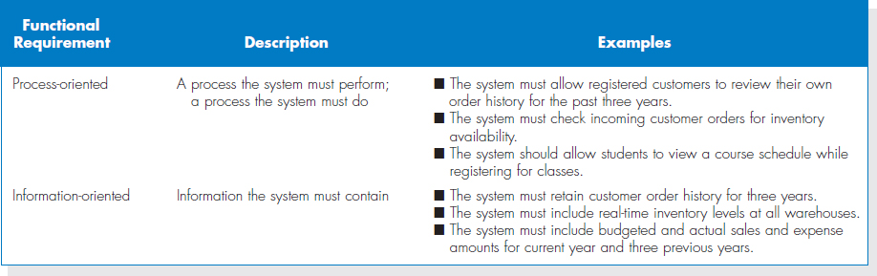

**FIGURE 3-1** Functional Requirements

Process models ([Chapter 5](http://proquestcombo.safaribooksonline.com.ezproxy.umuc.edu/9781118057629/chapter_5_process_modeling#chap05)) are used to explain the relationship of functions/ processes to the system users, how the functions/processes relate to each other, how data is entered and produced by functions/processes, and how functions/processes create and use stored data. Process models help clarify the software components that will be needed to accomplish the functional requirements. In addition, the functional requirements begin to define the data that must be kept track of in order to accomplish the user tasks. The data component of the system is defined in the data model ([Chapter 6](http://proquestcombo.safaribooksonline.com.ezproxy.umuc.edu/9781118057629/chapter_6_data_modeling#chap06)).

**YOUR TURN: 3-1 IDENTIFYING REQUIREMENTS**

|  |
| --- |
| **O**ne of the most common mistakes made by new analysts is to confuse functional and nonfunctional requirements. Pretend that you received the following list of requirements for a sales system:  Requirements for Proposed System:  The system should…   1. be accessible to Web users. 2. include the company standard logo and color scheme. 3. restrict access to profitability information. 4. include actual and budgeted cost information. 5. provide management reports. 6. include sales information that is updated at least daily 7. have 2-second maximum response time for predefined queries and 10-minute maximum response time for ad hoc queries. 8. include information from all company subsidiaries. 9. Print subsidiary reports in the primary language of the subsidiary. 10. Provide monthly rankings of salesperson performance.   **QUESTIONS**:   1. Which requirements are functional business requirements? Provide two additional examples. 2. Which requirements are nonfunctional business requirements? What kind of nonfunctional requirements are they? Provide two additional examples. |

User requirements and functional requirements defined in the analysis phase will flow into the design phase, where they evolve to become more technical, describing *how* the system will be implemented. Requirements in the design phase reflect the developer's perspective, and they usually are called *system requirements*. These requirements focus on describing how to create the software product that will be produced from the project. More will be said about system requirements in Part 3 of the textbook.

Before we continue, we want to stress that it can be difficult to draw a black-and-white dividing line between these categories of requirement—and, confusingly, some companies use the terms interchangeably. The important thing to remember is that a requirement is a statement of what the system must do, and the focus of requirements will change over time as the project moves from planning to analysis to design to implementation. Requirements evolve from broad statements of overall business needs from the system to detailed statements of the business capabilities that a system should support to detailed technical statements of the way in which the capabilities will be implemented in the new system.

The final category of requirements is *nonfunctional requirements*. The IIBA defines this group of requirements as “the quality attributes, design, and implementation constraints, and external interfaces which a product must have.”[4](http://proquestcombo.safaribooksonline.com.ezproxy.umuc.edu/9781118057629/navPoint-48#fn.004_11_chap03) Although the term “nonfunctional” is not very descriptive, this requirement category includes important behavioral properties that the system must have, such as performance and usability. The ability to access the system through a mobile device would be considered a nonfunctional requirement. Nonfunctional requirements are primarily used in the design phase when decisions are made about the user interface, the hardware and software, and the system's underlying architecture. Many of these requirements will be discovered during conversations with users in the analysis phase, however, and should be recorded as they are discovered.

[Figure 3-2](http://proquestcombo.safaribooksonline.com.ezproxy.umuc.edu/9781118057629/navPoint-39#fig3-2) lists different kinds of nonfunctional requirements and examples of each kind. Notice that the nonfunctional requirements describe a variety of system characteristics: operational, performance, security, and cultural and political. These characteristics do not describe business processes or information, but they are very important in understanding what the final system should be like. For example, the project team needs to know whether a system must be highly secure, requires sub-second response time, or has to reach a multilingual customer base. These requirements will affect design decisions that will be made in the design phase, particularly architecture design, so we will revisit them in detail in [Chapter 8](http://proquestcombo.safaribooksonline.com.ezproxy.umuc.edu/9781118057629/chapter_8_architecture_design#chap08). The goal at this point is to identify any major issues. In addition, if the methodology in use includes developing test plans during analysis, then these requirements will be important in establishing testing benchmarks that will be needed later.

### The Process of Determining Requirements

Both business and IT perspectives are needed to determine requirements during the analysis phase. Systems analysts may not understand the true business needs of the users. A recent study by the Standish Group found that the lack of user involvement is the top reason for IT project failure.[5](http://proquestcombo.safaribooksonline.com.ezproxy.umuc.edu/9781118057629/navPoint-48#fn.005_11_chap03) On the other hand, the business users may not be aware of the opportunities that a new technology may offer. It is important that the team carefully considers the underlying business process and how best to support that business process with information system technology.

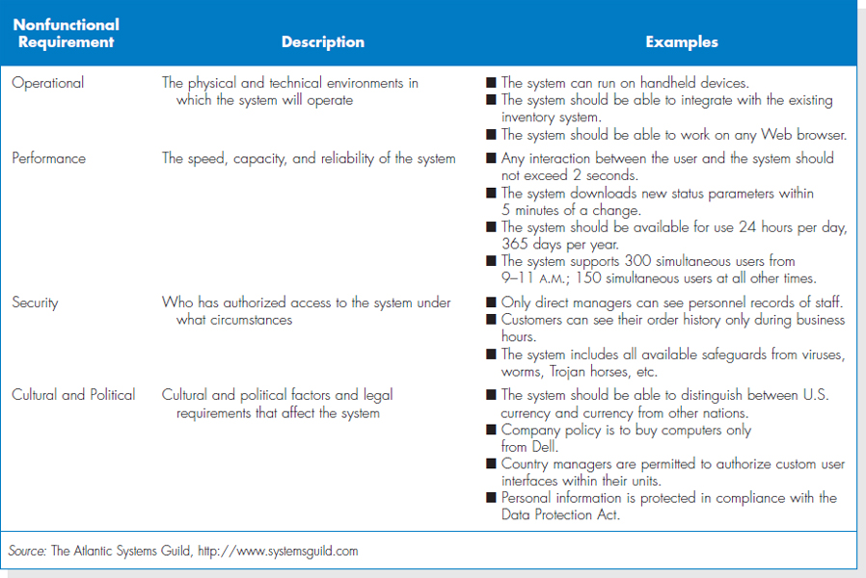

**FIGURE 3-2** Nonfunctional Requirements

**CONCEPTS IN ACTION: 3-A WHAT CAN HAPPEN IF YOU IGNORENONFUNCTIONAL REQUIREMENTS**

|  |
| --- |
| **I** once worked on a consulting project in which my manager created a requirements definition without listing nonfunctional requirements. The project was then estimated based on the requirements definition and sold to the client for $5,000. In my manager's mind, the system that we would build for the client would be a very simple stand-alone system running on current technology. It shouldn't take more than a week to analyze, design, and build.  Unfortunately, the client had other ideas. They wanted the system to be used by many people in three different departments, and they wanted the ability for any number of people to work on the system concurrently. The Technology they had in place was antiquated, but nonetheless they wanted the system to run effectively on the existing equipment. Because we didn't set the project scope properly by including our assumptions about non-functional requirements in the requirements definition, we basically had to do whatever they wanted.  The capabilities they wanted took weeks to design and program. The project ended up taking four months, and the final project cost was $250,000. Our company had to pick up the tab for everything except the agreed upon $5,000. This was by far the most frustrating project situation I ever experienced.  *Barbara Wixom* |

A good analogy is building a house or an apartment. We have all lived in a house or apartment, and most of us have some understanding of what we would like in our homes. If we were asked to design a dwelling from scratch, however, it would be a challenge because we lack appropriate design skills and technical engineering skills. Likewise, an architect acting alone would probably miss some of our unique requirements.

Therefore, the most effective approach is to have both businesspeople and analysts working together to determine requirements. In fact, the analysis phase involves significant interactions with people who have an interest in the new system (often called stakeholders). One of the first tasks for the analyst is to identify the primary sources of requirements, including the project sponsor, project champion(s), all users of the system (both direct and indirect), and possibly others. It is important that all user perspectives are included.

The analyst must also consider how best to elicit the requirements from the stakeholders. There are a variety of elicitation techniques that can be used to acquire information, including interviews, questionnaires, observation, joint application development (JAD), and document analysis. We will discuss these techniques in the next section. The information gathered by these techniques is critically analyzed and used to craft the requirements definition statement. The analyst works with the entire project team and the business users to verify, change, and complete the list of requirements and, if necessary, to prioritize the importance of the requirements that are identified. During this process, use cases, process models, and data models may be used to clarify and define the ideas for the new system. This process continues throughout the analysis phase, and the requirements definition evolves over time as new requirements are identified and as the project moves into later phases of the SDLC.

Beware: The evolution of the requirements definition must be carefully managed. Keeping the requirements list tight and focused is a key to project success. The project team cannot keep adding new items to the requirements definition or the system will keep growing and growing and never get finished. Instead, the project team carefully identifies requirements and evaluates which ones fit within the system scope. When a requirement reflects a real business need, but is not within the scope of the current system or current release, it should be evaluated in terms of its importance and impact on time and budget. It may be that the requirement is essential enough to add to the current project, along with appropriate adjustments to the project scope, budget, and time frame. We should not assume that the requirements for the project can never be changed. However, it is also possible that the requirement might be added to a list of future requirements or given a low priority. The management of requirements (and system scope) is one of the hardest parts of managing a project!

### The Requirements Definition Statement

The requirements definition statement—usually just called the *requirements definition*—is a straightforward text report that simply lists the functional and non-functional requirements in an outline format. [Figure 3-3](http://proquestcombo.safaribooksonline.com.ezproxy.umuc.edu/9781118057629/navPoint-39#fig3-3) shows a sample requirements definition for Holiday Travel Vehicles, a fictitious recreational vehicle dealership.

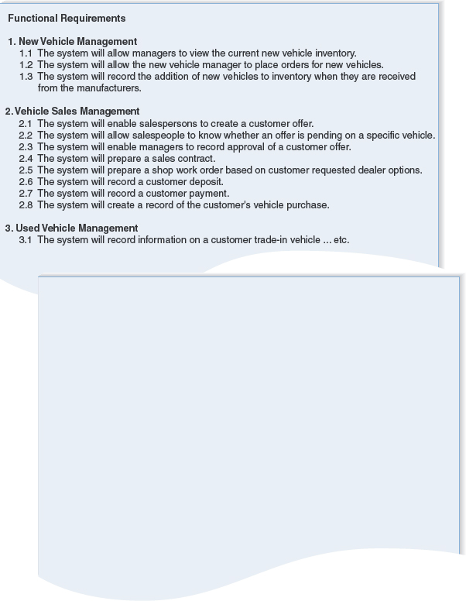

**FIGURE 3-3** Sample Requirements Definition

As shown in [Figure 3-3](http://proquestcombo.safaribooksonline.com.ezproxy.umuc.edu/9781118057629/navPoint-39#fig3-3), it is common to number the requirements in a legal or outline format so that each requirement is clearly identified. It is important that the requirements be identified with unique numbers so that each requirement can be easily tracked through the entire development process. For clarity, the requirements are typically grouped into functional and nonfunctional groupings. Then, within each of those groups, they are classified further by the type of requirement or by business area.

Sometimes, requirements are prioritized on the requirements definition statement. They can be ranked as having “high,” “medium,” or “low” importance in the new system, or they can be labeled with the version of the system that will address the requirement (e.g., release 1, release 2, release 3). This practice is particularly important with RAD methodologies that deliver requirements in batches by developing incremental versions of the system.

The most *obvious* purpose of the requirements definition is to provide a clear statement of what the new system should do in order to achieve the system vision described in the system request. The use cases, process models, and data models provide additional explanatory content in different formats. A critically *important* purpose of the requirements definition, however, is to define the scope of the system. The document describes to the analysts exactly what the final system needs to do. In addition, it serves to establish the users' expectations for the system. If and when discrepancies or misunderstandings arise, the document serves as a resource for clarification.

## Interviews (under the Requirements Elicitation in Practice section)

<https://learning.oreilly.com/library/view/System+Analysis+and+Design,+Fifth+Edition/9781118057629/11_chap03.html#chap03-sec010>

## Requirements Elicitation in Practice

Before discussing the five requirements elicitation techniques in detail, a few practical tips are in order. First, the analyst should recognize that important side effects of the requirements definition process include building political support for the project and establishing trust and rapport between the project team and the ultimate users of the system. Every contact and interaction between the analyst and a potential business user or manager is an opportunity to generate interest, enthusiasm, and commitment to the project. Therefore, the analyst should be prepared to make good use of these opportunities as they arise during the requirements definition process.

Second, the analyst should carefully determine who is included in the requirements definition process. The choice to include (or exclude) someone is significant; involving someone in the process implies that the analyst views that person as an important resource and values his or her opinions. You *must* include all of the key *stakeholders* (the people who can affect the system or who will be affected by the system). This might include managers, employees, staff members,and even some customers and suppliers. Also, be sensitive to the fact that some people may have significant influence within the organization even if they do not rank high in the formal organizational hierarchy. If you do not involve a key person, that individual may feel slighted, causing problems during implementation (e.g., saying “I could have told them this might happen, but they didn't ask *me!” )*.

Finally, do everything possible to respect the time commitment that you are asking the participants to make. The best way to do this is to be fully prepared and to make good use of all the types of requirements elicitation techniques. Although, as we will see, interviewing is the most commonly used technique, other indirect methods may help the analyst develop a basic understanding of the business domain so that the direct techniques are more productive. In general, a useful strategy for the analyst to employ is to begin requirements gathering by interviewing senior managers to gain an understanding of the project and get the “big picture.” These preliminary interviews can then be followed by document analysis and, possibly, observation of business processes to learn more about the business domain, the vocabulary, and the as-is system. More interviews may then follow to collect the rest of the information needed to understand the as-is system.

In our experience, identifying improvements is most commonly done through JAD sessions because these sessions enable the users and key stakeholders to work together and create a shared understanding of the possibilities for the to-be system. Occasionally, these JAD sessions are followed by questionnaires sent to a much larger group of users or potential users to get a broad range of opinions. The concept for the to-be system is frequently developed through interviews with senior managers, followed by JAD sessions with users of all levels, to make sure that the key requirements of the new system are well understood.

In this section, we focus on the five most commonly used requirements elicitation techniques: interviews, JAD sessions, questionnaires, document analysis, and observation.

### Interviews

The *interview* is the most commonly used requirements elicitation technique. After all, it is natural—usually, if you need to know something, you ask someone. In general, interviews are conducted one on one (one interviewer and one interviewee), but sometimes, due to time constraints, several people are interviewed at the same time. There are five basic steps to the interview process: selecting interviewees, designing interview questions, preparing for the interview, conducting the interview, and postinterview follow-up.[6](http://proquestcombo.safaribooksonline.com.ezproxy.umuc.edu/9781118057629/navPoint-48#fn.006_11_chap03)

**Selecting Interviewees** An *interview schedule* should be created, listing who will be interviewed, the purpose of the interview, and where and when it will take place. (See [Figure 3-4](http://proquestcombo.safaribooksonline.com.ezproxy.umuc.edu/9781118057629/navPoint-41#fig3-4).) The schedule can be an informal list that is used to help set up meeting times or a formal list that is incorporated into the work plan. The people who appear on the interview schedule are selected on the basis of the analyst's information needs. The project sponsor, key business users, and other members of the project team can help the analyst determine who in the organization can best provide important information about requirements. These people are listed on the interview schedule in the order in which they should be interviewed.

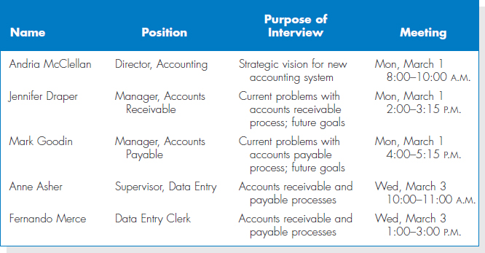

**FIGURE 3-4** Sample Interview Schedule

People at different levels of the organization will have different viewpoints on the system, so it is important to include both managers who manage the processes and staff who actually perform the processes to gain both high-level and low-level perspectives on an issue. Also, the kinds of interview subjects that you need may change over time. For example, at the start of the project the analyst has a limited understanding of the as-is business process. It is common to begin by interviewing one or two senior managers to get a strategic view and then move to mid-level managers who can provide broad, overarching information about the business process and the expected role of the system being developed. Once the analyst has a good understanding of the big picture, lower-level managers and staff members can fill in the exact details of how the process works. Like most other things about systems analysis, this is an iterative process—starting with senior managers, moving to mid-level managers, then staff members, back to mid-level managers, and so on, depending upon what information is needed along the way.

It is quite common for the list of interviewees to grow, often by 50%-75%. As you interview people, you likely will identify more information that is needed and additional people who can provide the information.

**CONCEPTS IN ACTION: 3-B SELECTING THE WRONG PEOPLE**

|  |
| --- |
| **I**n 1990, I led a consulting team for a major development project for the U.S. Army. The goal was to replace eight existing systems used on virtually every Army base across the United States. The as-is process and data models for these systems had been built, and our job was to identify improvement opportunities and develop to-be process models for each of the eight systems.  For the first system, we selected a group of mid-level managers (captains and majors) recommended by their commanders as being the experts in the system under In 1990, I led a consulting team for a construction. These individuals were the first and second line managers of the business function. The individuals were expert at managing the process, but did not know the exact details of how the process worked. The resulting to-be process model was very general and nonspecific.  *Alan Dennis*  **QUESTION**:  Suppose you were in charge of the project. Create an interview schedule for the remaining seven projects. |

**Designing Interview Questions** There are three types of interview questions: closed-ended questions, open-ended questions, and probing questions. *Closed-ended questions* require a specific answer. You can think of them as being similar to multiple choice or arithmetic questions on an exam. (See [Figure 3-5](http://proquestcombo.safaribooksonline.com.ezproxy.umuc.edu/9781118057629/navPoint-41#fig3-5).) Closed-ended questions are used when the analyst is looking for specific, precise information (e.g., how many credit card requests are received per day). In general, precise questions are best. For example, rather than asking “Do you handle a lot of requests?” it is better to ask “How many requests do you process per day?”

Closed-ended questions enable analysts to control the interview and obtain the information they need. However, these types of questions don't uncover *why* the answer is the way it is, nor do they uncover information that the interviewer does not think to ask ahead of time.

*Open-ended questions* are those that leave room for elaboration on the part of the interviewee. They are similar in many ways to essay questions that you might find on an exam. (See [Figure 3-5](http://proquestcombo.safaribooksonline.com.ezproxy.umuc.edu/9781118057629/navPoint-41#fig3-5) for examples.) Open-ended questions are designed to gather rich information and give the interviewee more control over the information that is revealed during the interview. Sometimes the subjects the interviewee chooses to discuss uncover information that is just as important as the answer (e.g., if the interviewee talks only about other departments when asked for problems, it may suggest that he or she is reluctant to admit his or her own department's problems).

The third type of question is the *probing question*. Probing questions follow up on what has just been discussed in order for the interviewer to learn more, and they often are used when the interviewer is unclear about an interviewee's answer. They encourage the interviewee to expand on or to confirm information from a previous response, and they are a signal that the interviewer is listening and interested in the topic under discussion. Many beginning analysts are reluctant to use probing questions because they are afraid that the interviewee might be offended at being challenged or because they believe it shows that they didn't understand what the interviewee said. When done politely, probing questions can be a powerful tool in requirements discovery.

In general, you should not ask questions about information that is readily available from other sources. For example, rather than asking what information is used to perform to a task, it is simpler to show the interviewee a form or report (see document analysis later) and ask what information on it is used. This helps focus the interviewee on the task and saves time, because he or she does not need to describe the information in detail—he or she just needs to point it out on the form or report.

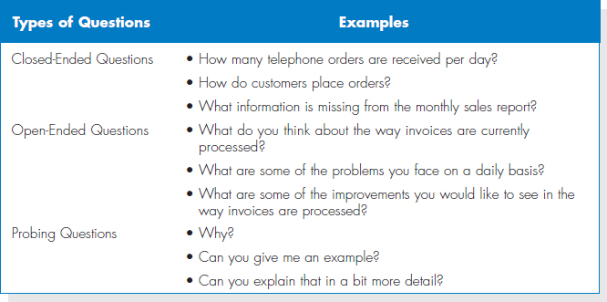

**FIGURE 3-5** Three Types of Questions

Your interview questions should anticipate the type of information the interviewee is likely to know. Managers are often somewhat removed from the details of daily business processes and so might be unable to answer questions about them, whereas lower-level staff members could readily respond. Conversely, lower-level employees may not be able to answer broad, policy-oriented questions, while managers could. Since no one wants to appear ignorant, avoid confounding your interviewees with questions outside their areas of knowledge.

No type of question is better than another, and usually a combination of questions is used during an interview. At the initial stage of an IS development project the as-is process can be unclear, so the interview process begins with *unstructured interviews*, interviews that seek a broad and roughly defined set of information. In this case, the interviewer has a general sense of the information needed, but few closed-ended questions to ask. These are the most challenging interviews to conduct because they require the interviewer to ask open-ended questions and probe for important information “on the fly.”

As the project progresses, the analyst comes to understand the business process much better, and he or she needs very specific information about how business processes are performed (e.g., exactly how a customer credit request is approved). At this time, the analyst conducts*structured interviews* in which specific sets of questions are developed prior to the interviews. There usually are more closed-ended questions in a structured interview than in the unstructured approach.

No matter what kind of interview is being conducted, interview questions must be organized into a logical sequence so that the interview flows well. For example, when trying to gather information about the current business process, the analyst will find it useful to move in logical order through the process or from the most important issues to the least important.

There are two fundamental approaches to organizing the interview questions: top-down or bottom-up; see [Figure 3-6](http://proquestcombo.safaribooksonline.com.ezproxy.umuc.edu/9781118057629/navPoint-41#fig3-6). With the *top-down interview*, the interviewer starts with broad, general issues and gradually works towards more specific ones. With the *bottom-up interview*, the interviewer starts with very specific questions and moves to broad questions. In practice, analysts mix the two approaches, starting with broad general issues, moving to specific questions, and then back to general issues.

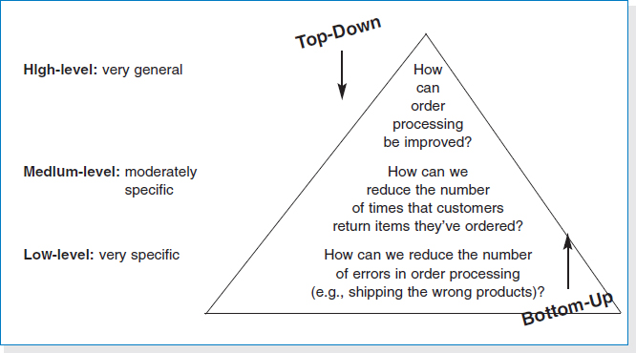

**FIGURE 3-6** Top-Down and Bottom-Up Questioning Strategies

The top-down approach is an appropriate strategy for most interviews. (It is certainly the most common approach.) The top-down approach enables the interviewee to become accustomed to the topic before he or she needs to provide specifics. It also enables the interviewer to understand the issues before moving to the details, because the interviewer may not have sufficient information at the start of the interview to ask very specific questions. Perhaps most importantly, the top-down approach enables the interviewee to raise a set of big-picture issues before becoming enmeshed in details, so the interviewer is less likely to miss important issues.

One case in which the bottom-up strategy may be preferred is when the analyst already has gathered a lot of information about issues and just needs to fill in some holes with details. Or, bottom-up may be appropriate if lower-level staff members feel threatened or are unable to answer high-level questions. For example, “How can we improve customer service?” may be too broad a question for a customer service clerk, whereas a specific question is readily answerable (e.g., “How can we speed up customer returns?” ). In any event, all interviews should begin with non-controversial questions first and then gradually move into more contentious issues after the interviewer has developed some rapport with the interviewee.

**Preparing for the Interview** It is important to prepare for the interview in the same way that you would prepare to give a presentation. You should have a general interview plan which lists the questions that you will ask in the appropriate order; anticipates possible answers and provides how you will follow up with them; and identifies segues between related topics. Confirm the areas in which the interviewee has knowledge so you do not ask questions that he or she cannot answer. Review the topic areas, the questions, and the interview plan, and clearly decide which ones have the greatest priority in case you run out of time.

In general, structured interviews with closed-ended questions take more time to prepare than unstructured interviews. So, some beginning analysts prefer unstructured interviews, thinking that they can “wing it.” This is very dangerous and often counterproductive, because any information not gathered in the first interview would have to be obtained by follow-up efforts, and most people do not like to be interviewed repeatedly about the same issues.

Be sure to prepare the interviewee as well. When you schedule the interview, inform the interviewee of the reason for the interview and the areas you will be discussing far enough in advance so that he or she has time to think about the issues and organize his or her thoughts. This is particularly important when you are an outsider to the organization and for interviewing lower-level employees who often are not asked for their opinions and who may be uncertain about why you are interviewing them.

**Conducting the Interview** When you start the interview, the first goal is to build rapport with the interviewee so that he or she trusts you and is willing to tell you the whole truth, not just give the answers that he or she thinks you want. You should appear to be professional and an unbiased, independent seeker of information. The interview should start with an explanation of why you are there and why you have chosen to interview the person, and then move into your planned interview questions.

It is critical to carefully record all the information that the interviewee provides. In our experience, the best approach is to take careful notes—write down *everything* the interviewee says, even if it does not appear immediately relevant. Don't be afraid to ask the person to slow down or to pause while you write, because this is a clear indication that the interviewee's information is important to you. One potentially controversial issue is whether or not to tape-record the interview. Recording ensures that you do not miss important points, but it can be intimidating for the interviewee. Most organizations have policies or generally accepted practices about the recording of interviews, so find out what they are before you start an interview. If you are worried about missing information and cannot tape the interview, then bring along a second person to take detailed notes.

As the interview progresses, it is important that you understand the issues that are discussed. If you do not understand something, be sure to ask. Don't be afraid to ask “dumb questions,” because the only thing worse than appearing “dumb” is to *be* “dumb” by not understanding something that you could have cleared up by questioning. If you don't understand something during the interview, you certainly won't understand it afterward. Try to recognize and define jargon, and be sure to clarify jargon you do not understand. One good strategy to increase your understanding during an interview is to periodically summarize the key points that the interviewee is communicating. This avoids misunderstandings and also demonstrates that you are listening.

Finally, be sure to separate facts from opinion. The interviewee may say, for example, “We process too many credit card requests.” This is an opinion, and it is useful to follow this up with a probing question requesting support for the statement (e.g., “Oh, how many do you process in a day?” ). It is helpful to check the facts because any differences between the facts and the interviewee's opinions can point out key areas for improvement. Suppose that the interviewee complains about a high or increasing number of errors, but the logs show that errors have been decreasing. This suggests that errors are viewed as a very important problem that should be addressed by the new system, even if they are declining.

As the interview draws to a close, be sure to give the interviewee time to ask questions or provide information that he or she thinks is important but was not part of your interview plan. In most cases, the interviewee will have no additional concerns or information, but in some cases this will lead to unanticipated, but important information. Likewise, it can be useful to ask the interviewee if there are other people who should be interviewed. Make sure that the interview ends on time. (If necessary, omit some topics or plan to schedule another interview.)

As a last step in the interview, briefly explain what will happen next. (See the next section.) You don't want to prematurely promise certain features in the new system or a specific delivery date, but you do want to reassure the interviewee that his or her time was well spent and very helpful to the project.

Beginning systems analysts may naively think that conducting an interview is as easy as conversing with a friend. Unfortunately, this is almost never true. Interviewees often are not able or willing to hand over the needed information in a neat, organized fashion. In some cases, they may not want to share what they know at all. Analysts should hone their interpersonal skills to improve their interviewing success. (See Practical Tip 3-1.)

**PRACTICAL TIP: 3-1 DEVELOPING INTERPERSONAL SKILLS**

|  |
| --- |
| ***I****nterpersonal skills* are those that enable you to develop rapport with others, and they are very important for interviewing. They help you to communicate with others effectively. Some people develop good interpersonal skills at an early age; they simply seem to know how to communicate and interact with others. Other people are less “lucky” and need to work hard to develop their skills.  Interpersonal skills, like most skills, can be learned. Here are some tips:   * **Don't worry, be happy.** Happy people radiate confidence and project their feelings on others. Try interviewing someone while smiling and then interviewing someone else while frowning and see what happens! * **Pay attention.** Pay attention to what the other person is saying (which is harder than you might think). See how many times you catch yourself with your mind on something other than the conversation at hand. * **Summarize key points.** At the end of each major theme or idea that someone explains, you should repeat the key points back to the speaker (e.g., “Let me make sure I understand. The key issues are …” ). This demonstrates that you consider the information important— and also forces you to pay attention. (You can't repeat what you didn't hear.) * **Be succinct.** When you speak, be succinct. The goal in interviewing (and in much of life) is to learn, not to impress. The more you speak, the less time you give to others. * **Be honest.** Answer all questions truthfully, and if you don't know the answer, say so. * **Watch body language (yours and theirs).** The way a person sits or stands conveys much information. In general, a person who is interested in what you are saying sits or leans forward, makes eye contact, and often touches his or her face. A person leaning away from you or with an arm over the back of a chair is disinterested. Crossed arms indicate defensiveness or uncertainty, while “steepling” (sitting with hands raised in front of the body with fingertips touching) indicates a feeling of superiority. |

**Post-interview Follow-up** After the interview is over, the analyst needs to prepare an *interview report* that describes the information from the interview ([Figure 3-7](http://proquestcombo.safaribooksonline.com.ezproxy.umuc.edu/9781118057629/navPoint-41#fig3-7)). The report contains*interview notes*, information that was collected over the course of the interview and is summarized in a useful format. In general, the interview report should be written within 48 hours of the interview, because the longer you wait, the more likely you are to forget information.

**CONCEPTS IN ACTION: 3-C THE RELUCTANT INTERVIEWEE**

|  |
| --- |
| **E**arly in my consulting career I was sent to a client organization with the goal of interviewing the only person in the organization who knew how the accounts receivable system worked, and developing documentation for that system (nonexistent at the time). The interviewee was on time, polite, and told me absolutely nothing of value about the accounts receivable system, despite my best efforts over several interview sessions. Eventually, my manager called me off this project, and our attempt to document this system was abandoned.  *Roberta Roth*  **QUESTIONS**:   1. Why do you suppose the interviewee was so uncooperative? 2. Can you think of any ways to avoid this failed outcome? |

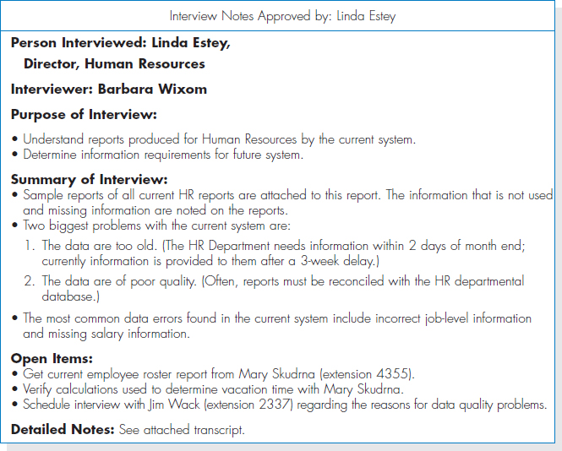

**FIGURE 3-7** Interview Report

Often, the interview report is sent to the interviewee with a request to read it and inform the analyst of clarifications or updates. Make sure the interviewee is convinced that you genuinely want his or her corrections to the report. Usually, there are few changes, but the need for any significant changes suggests that a second interview will be required. Never distribute someone's information without prior approval.

## Joint Application Development (under the Requirements Elicitation in Practice section)

<https://learning.oreilly.com/library/view/System+Analysis+and+Design,+Fifth+Edition/9781118057629/11_chap03.html#chap03-sec010>

### Joint Application Development (JAD)

*Joint application development* (or *JAD* as it is more commonly known) is an information gathering technique that allows the project team, users, and management to work together to identify requirements for the system. IBM developed the JAD technique in the late 1970s, and it is often the most useful method for collecting information from users.[7](http://proquestcombo.safaribooksonline.com.ezproxy.umuc.edu/9781118057629/navPoint-48#fn.007_11_chap03) Capers Jones claims that JAD can reduce scope creep by 50%, and it prevents the requirements for a system from being too specific or too vague, both of which can cause trouble during later stages of the SDLC.[8](http://proquestcombo.safaribooksonline.com.ezproxy.umuc.edu/9781118057629/navPoint-48#fn.008_11_chap03)JAD is a structured process in which 10 to 20 users meet under the direction of a *facilitator*skilled in JAD techniques. The facilitator is a person who sets the meeting agenda and guides the discussion, but does not join in the discussion as a participant. He or she does not provide ideas or opinions on the topics under discussion and remains neutral during the session. The facilitator must be an expert in both group process techniques and systems analysis and design techniques. One or two *scribes* assist the facilitator by recording notes, making copies, and so on. Often, the scribes will use computers and CASE tools to record information as the JAD session proceeds.

The JAD group meets for several hours, several days, or several weeks until all of the issues have been discussed and the needed information is collected. Most JAD sessions take place in a specially prepared meeting room, away from the participants' offices, so that they are not interrupted. The meeting room is usually arranged in a U shape so that all participants can easily see each other. (See [Figure 3-8](http://proquestcombo.safaribooksonline.com.ezproxy.umuc.edu/9781118057629/navPoint-41#fig3-8).) At the front of the room (the open part of the “U”), there is a whiteboard, flip chart and/or overhead projector for use by the facilitator, who leads the discussion.

One problem with JAD is that it suffers from the traditional problems associated with groups: Sometimes people are reluctant to challenge the opinions of others (particularly their boss), a few people often dominate the discussion, and not everyone participates. In a 15-member group, for example, if everyone participates equally, then each person can talk for only 4 minutes each hour and must listen for the remaining 56 minutes—not a very efficient way to collect information.

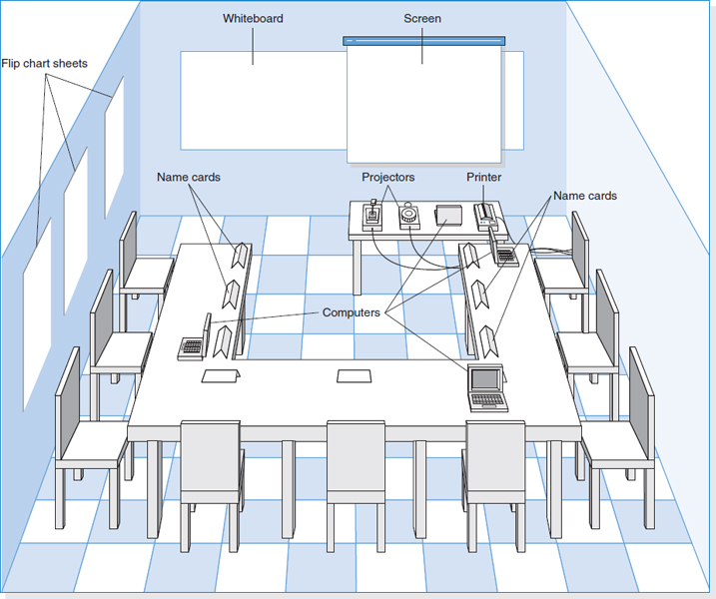

**FIGURE 3-8** Joint Application Development Meeting Room

**YOUR TURN: 3-2 INTERVIEW PRACTICE**

|  |
| --- |
| **I**nterviewing is not as simple as it first appears. Select two people from class to go to the front of the room to demonstrate an interview. (This also can be done in groups.) Have one person be the interviewer, and the other the interviewee. The interviewer should conduct a 5-minute interview regarding the school course registration system. Gather information about the existing system and how the system can be improved. If there is time, repeat with another pair.  QUESTIONS:   1. Describe the body language of the interview pair. 2. What kind of interview was conducted? 3. What kinds of questions were asked? 4. What was done well? How could the interview be improved? |

*Electronic JAD*, or *e-JAD*, attempts to overcome these problems by the use of groupware. In an e-JAD meeting room, each participant uses special software on a networked computer to anonymously submit ideas, view all ideas generated by the group, and rate and rank ideas through voting. The facilitator uses the electronic tools of the e-JAD system to guide the group process, maintaining anonymity and enabling the group to focus on each idea's merits and not the power or rank of the person who contributed the idea. In this way, all participants can contribute at the same time, without fear of reprisal from people with differing opinions. Initial research suggests that e-JAD can reduce the time required to run JAD sessions by 50%-80%.[9](http://proquestcombo.safaribooksonline.com.ezproxy.umuc.edu/9781118057629/navPoint-48#fn.009_11_chap03)

**Selecting Participants** Selecting JAD participants is done in the same basic way as selecting interview participants. Participants are selected on the basis of information they can contribute, to provide a broad mix of organizational levels, and to build political support for the new system. The need for all JAD participants to be away from their offices at the same time can be a major problem. The office may need to be closed or run with a skeleton staff until the JAD sessions are complete.

Ideally, the participants who are released from regular duties to attend the JAD sessions should be the very best people in that business unit. However, without strong management support, JAD sessions can fail, because those selected to attend the JAD session are people who are less likely to be missed (i.e., the least competent people).

The facilitator should be someone who is an expert in JAD or e-JAD techniques and, ideally, someone who has experience with the business under discussion. In many cases, the JAD facilitator is a consultant external to the organization because the organization may not have a regular day-to-day need for JAD or e-JAD expertise. Developing and maintaining this expertise in-house can be expensive.

**Designing the JAD Session** JAD sessions can run from as little as a half day to several weeks, depending upon the size and scope of the project. In our experience, most JAD sessions tend to last 5 to 10 days spread over a 3-week period. Most e-JAD sessions tend to last 1 to 4 days in a 1-week period. JAD and e-JAD sessions usually move beyond the collection of information into producing analysis deliverables. For example, the users and the analysts collectively can create use cases, process models, or the requirements definition.

As with interviewing, JAD success depends upon a careful plan. JAD sessions usually are designed and structured along the same principles as interviews. Most JAD sessions are designed to collect specific information from users, and this requires the development of a set of questions prior to the meeting. A difference between JAD and interviewing is that all JAD sessions are structured—they *must* be carefully planned. In general, closed-ended questions are seldom used, because they do not spark the open and frank discussion that is typical of JAD. In our experience, it is better to proceed top-down in JAD sessions when gathering information. Typically, 30 minutes is allocated to each separate agenda item, and frequent breaks are scheduled throughout the day because participants tire easily.

**Preparing for the JAD Session** As with interviewing, it is important to prepare the analysts and participants for the JAD session. Because the sessions can go beyond the depth of a typical interview and usually are conducted off-site, participants can be more concerned about how to prepare. It is important that the participants understand what is expected of them. If the goal of the JAD session, for example, is to develop an understanding of the current system, then participants can bring procedure manuals and documents with them. If the goal is to identify improvements for a system, then they can think about how they would improve the system prior to the JAD session.

**Conducting the JAD Session** Most JAD sessions try to follow a formal agenda, and most have formal *ground rules* that define appropriate behavior. Common ground rules include following the schedule, respecting others' opinions, accepting disagreement, and ensuring that only one person talks at a time.

The role of the JAD facilitator can be challenging. Many participants come to the JAD session with strong feelings about the system being discussed. Channeling these feelings so that the session moves forward in a positive direction and getting participants to recognize and accept—but not necessarily agree on—opinions and situations different from their own requires significant expertise in systems analysis and design, JAD, and interpersonal skills. Few systems analysts attempt to facilitate JAD sessions without being trained in JAD techniques, and most apprentice with a skilled JAD facilitator before they attempt to lead their first session.

The JAD facilitator performs three key functions. First, he or she ensures that the group sticks to the agenda. The only reason to digress from the agenda is when it becomes clear to the facilitator, project leader, and project sponsor that the JAD session has produced some new information that is unexpected and requires the JAD session (and perhaps the project) to move in a new direction. When participants attempt to divert the discussion away from the agenda, the facilitator must be firm, but polite, in leading the discussion back to the agenda and getting the group back on track.

Second, the facilitator must help the group understand the technical terms and jargon that surround the system development process and help the participants understand the specific analysis techniques used. Participants are experts in their business area, but they probably are not experts in systems analysis. The facilitator must therefore minimize the learning required and teach participants how to effectively provide the right information.

Third, the facilitator records the group's input on a public display area, which can be a whiteboard, flip chart, or computer display. He or she structures the information that the group provides and helps the group recognize key issues and important solutions. Under no circumstance should the facilitator insert his or her opinions into the discussion. The facilitator*must* remain neutral at all times and simply help the group through the process. The moment the facilitator offers an opinion on an issue, the group will no longer see him or her as a neutral party, but rather as someone who could be attempting to sway the group into some predetermined solution.

However, this does not mean that the facilitator should not try to help the group resolve issues. For example, if two items appear to be the same to the facilitator, the facilitator should not say, “I think these may be similar.” Instead, the facilitator should ask, “Are these similar?” If the group decides that they are, the facilitator can combine them and move on. However, if the group decides that they are not similar (despite what the facilitator believes), the facilitator should accept the decision and move on. The group is *always* right, and the facilitator has no opinion.

It is common for the JAD participants to make use of a number of tools during the JAD session in order to fully define the new system. Use cases may be created to describe how the users will interact with the new system. Prototypes may be created to more fully understand the user interface or navigation through the system. Process models can be constructed to understand the software that will be developed, while a data model can be used to describe the data that will be captured and maintained. The facilitator and the analysts on the project team should use every tool at their disposal to help the participants clarify and define their needs for the new system.

**Post-JAD Follow-up** As with interviews, a JAD *post-session report* is prepared and circulated among session attendees. The post-session report is essentially the same as the interview report in [Figure 3-7](http://proquestcombo.safaribooksonline.com.ezproxy.umuc.edu/9781118057629/navPoint-41#fig3-7). Since the JAD sessions are longer and provide more information, it usually takes a week or two after the JAD session before the report is complete.

**YOUR TURN: 3-3 JAD PRACTICE**

|  |
| --- |
| **O**rganize yourselves into groups of four to seven people, and pick one person in each group to be the JAD facilitator. Using a blackboard, whiteboard, or flip chart, gather information about how the group performs some process (e.g., working on a class assignment, making a sandwich, paying bills, getting to class). How did the JAD session go? Based on your experience, what are some pros and cons of using JAD in a real organization? |

**PRACTICAL TIP: 3-2 MANAGING PROBLEMS IN JAD SESSIONS**

|  |
| --- |
| **I** have run more than a hundred JAD sessions and have learned several standard “facilitator tricks.” Here are some common problems and some ways to deal with them.   * **Reducing domination.** The facilitator should ensure that no one person dominates the group discussion. The only way to deal with someone who dominates is head on. During a break, approach the person, thank him or her for their insightful comments, and ask them to help you make sure that others also participate. * **Encouraging noncontributors.** Drawing out people who have participated very little is challenging because you want to bring them into the conversation so that they will contribute again. The best approach is to ask a direct factual question that you are *certain* they can answer. And it helps to ask the question using some repetition to give them time to think. For example “Pat, I know you've worked shipping orders a long time. You've probably been in the Shipping Department longer than anyone else. Could you help us understand exactly what happens when an order is received in Shipping?” * **Side discussions.** Sometimes participants engage in side conversations and fail to pay attention to the group. The easiest solution is simply to walk close to the people and continue to facilitate right in front of them. Few people will continue a side conversion when you are two feet from them and the entire group's attention is on you and them. * **Agenda merry-go-round.** The merry-go-round occurs when a group member keeps returning to the same issue every few minutes and won't let go. One solution is to let the person have five minutes to ramble on about the issue while you carefully write down every point on a flip chart or computer file. This flip chart or file is then posted conspicuously on the wall. When the person brings up the issue again, you interrupt them, walk to the paper and ask them what to add. If they mention something already on the list, you quickly interrupt, point out that it is there, and ask what other information to add. Don't let them repeat the same point, but write any new information. * **Violent agreement.** Some of the worst disagreements occur when participants really agree on the issues but don't realize that they agree because they are using different terms. An example is arguing whether a glass is half empty or half full; they agree on the facts, but can't agree on the words. In this case, the facilitator has to translate the terms into different words and find common ground so the parties recognize that they really agree. * **Unresolved conflict.** In some cases, participants don't agree and can't understand how to determine what alternatives are better. You can help by structuring the issue. Ask for criteria by which the group will identify a good alternative (e.g., “Suppose this idea really did improve customer service. How would I recognize the improved customer service?” ).Then once you have a list of criteria, ask the group to assess the alternatives using them. * **True conflict.** Sometimes, despite every attempt, participants just can't agree on an issue. The solution is to postpone the discussion and move on. Document the issue as an “open issue” and list it prominently on a flip chart. Have the group return to the issue hours later. Often the issue will resolve itself by then and you haven't wasted time on it. If the issue cannot be resolved later, move it to the list of issues to be decided by the project sponsor or some other more senior member of management. * **Use humor.** Humor is one of the most powerful tools a facilitator has and thus must be used judiciously. The best JAD humor is always in context; never tell jokes but take the opportunity to find the humor in the situation.   *Alan Dennis* |

## Questionnaires (under the Requirements Elicitation in Practice section)

<https://learning.oreilly.com/library/view/System+Analysis+and+Design,+Fifth+Edition/9781118057629/11_chap03.html#chap03-sec010>

A questionnaire is a set of written questions for obtaining information from individuals. Questionnaires often are used when there is a large number of people from whom information and opinions are needed. In our experience, questionnaires are commonly used for systems intended for use outside of the organization (e.g., by customers or vendors) or for systems with business users spread across many geographic locations. Most people automatically think of paper when they think of questionnaires, but today more questionnaires are being distributed in electronic form, either via e-mail or on the Web. Electronic distribution can save a significant amount of money, compared with distributing paper questionnaires.

**Selecting Participants** As with interviews and JAD sessions, the first step is to select the individuals to whom the questionnaire will be sent. However, it is not usual to select every person who could provide useful information. The standard approach is to select a *sample*, or subset, of people who are representative of the entire group. Sampling guidelines are discussed in most statistics books, and most business schools include courses that cover the topic, so we will not discuss it here. The important point in selecting a sample, however, is to realize that not everyone who receives a questionnaire will actually complete it. On average, only 30%–50% of paper and e-mail questionnaires are returned. Response rates for Web-based questionnaires tend to be significantly lower (often, only 5%–30%).

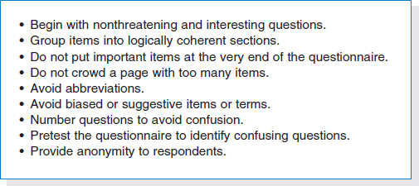

**FIGURE 3-9** Good Questionnaire Design

**Designing the Questionnaire** Developing good questions is critical for questionnaires because the information on a questionnaire cannot be immediately clarified for a confused respondent. Questions on questionnaires must be very clearly written and must leave little room for misunderstanding; therefore, closed-ended questions tend to be most commonly used. Questions must enable the analyst to clearly separate facts from opinions. Opinion questions often ask the respondent the extent to which they agree or disagree (e.g., “Are network problems common?” ), while factual questions seek more precise values (e.g., “How often does a network problem occur: once an hour, once a day, or once a week?” ). See [Figure 3-9](http://proquestcombo.safaribooksonline.com.ezproxy.umuc.edu/9781118057629/navPoint-41#fig3-9) for guidelines on questionnaire design.

Perhaps the most obvious issue—but one that is sometimes overlooked—is to have a clear understanding of how the information collected from the questionnaire will be analyzed and used. You must address this issue before you distribute the questionnaire, because it is too late afterward.

Questions should be relatively consistent in style so that the respondent does not have to read instructions for each question before answering it. It is generally a good practice to group related questions together to make them simpler to answer. Some experts suggest that questionnaires should start with questions important to respondents, so that the questionnaire immediately grabs their interest and induces them to answer it. Perhaps the most important step is to have several colleagues review the questionnaire and then pretest it with a few people drawn from the groups to whom it will be sent. It is surprising how often seemingly simple questions can be misunderstood.

**Administering the Questionnaire** The key issue in administering the questionnaire is getting participants to complete the questionnaire and send it back. Dozens of marketing research books have been written about ways to improve response rates. Commonly used techniques include clearly explaining why the questionnaire is being conducted and why the respondent has been selected; stating a date by which the questionnaire is to be returned; offering an inducement to complete the questionnaire (e.g., a free pen); and offering to supply a summary of the questionnaire responses. Systems analysts have additional techniques to improve responses rates inside the organization, such as personally handing out the questionnaire and personally contacting those who have not returned them after a week or two, as well as requesting the respondents' supervisors to administer the questionnaires in a group meeting.

**Questionnaire Follow-up** It is helpful to process the returned questionnaires and develop a questionnaire report soon after the questionnaire deadline. This ensures that the analysis process proceeds in a timely fashion and that respondents who requested copies of the results receive them promptly.

**YOUR TURN: 3-4 QUESTIONNAIRE PRACTICE**

|  |
| --- |
| **O**rganize yourselves into small groups. Have each person develop a short questionnaire to collect information about the frequency in which group members perform some process (e.g., working on a class assignment, making a sandwich, paying bills, getting to class), how long it takes them, how they feel about the process, and opportunities for improving the process.  Once everyone has completed his or her questionnaire, ask each member to pass it to the right and then complete his or her neighbor's questionnaire.  Pass the questionnaire back to the creator when it is completed.  **QUESTIONS**:   1. How did the questionnaire you completed differ from the one you created? 2. What are the strengths of each questionnaire? 3. How would you analyze the survey results if you had received 50 responses? 4. What would you change about the questionnaire that you developed? |

## Sampling

Sampling is widely used in business as a means of gathering useful information about a population. Data are gathered from samples and conclusions are drawn about the population as a part of the inferential statistics process. In the Decision Dilemma on maquiladora workers, a random sample of workers could be taken from a wide selection of companies in several industries in many of the key border cities. A carefully constructed questionnaire that is culturally sensitive to Mexicans could be administered to the selected workers to determine work attitudes, expectations, and cultural differences between workers and companies. The researchers could compile and analyze the data gleaned from the responses. Summaries and observations could be made about worker outlook and culture in the maquiladora program. Management and decision makers could then attempt to use the results of the study to improve worker performance and motivation. Often, a sample provides a reasonable means for gathering such useful decision-making information that might be otherwise unattainable and unaffordable.

### Reasons for Sampling

Taking a sample instead of conducting a census offers several advantages.

**1.** The sample can save money.

**2.** The sample can save time.

**3.** For given resources, the sample can broaden the scope of the study.

**4.** Because the research process is sometimes destructive, the sample can save product.

**5.** If accessing the population is impossible, the sample is the only option.

For a given number of questions from a survey or a given set of measurements obtained in a study, taking a sample versus a census can result in a savings of both money and time. For example, suppose an eight-minute telephone interview is conducted as part of a survey. Conducting such interviews with a sample of 100 customers is substantially less expensive and time-consuming than taking a census of 100,000 customers. If obtaining the outcomes of a study is a matter of urgency, sampling can produce results more quickly. With the volatility of the marketplace and the constant barrage of new competition and new ideas, sampling has a strong advantage over a census in terms of research turnaround time.

If resources allocated to a research project are fixed, more detailed information can be gathered by taking a sample than by conducting a census. With resources concentrated on fewer individuals or items, a study can be broadened in scope to allow more specialized questions and deeper investigation. As an example, one organization budgeted $80,000 to survey the opinions of its customers and opted to take a census instead of a sample by sending a mail survey to the entire population. The researchers mass-mailed thousands of copies of a brief 20-questionsurvey in which each question could be answered with a Yes or No response. One of the questions was, “Are you satisfied with the service that you received at the XYZ store?” For the same amount of money, the company could have taken a random sample from the population, held interactive one-on-one sessions with highly trained interviewers, and gathered detailed information about customer opinions and attitudes towards products, service, layout, availability, etc.

Some research processes are destructive to the product or item being studied. For example, if light bulbs are being tested to determine how long they burn or batteries are being discharged to determine how long they last, the light bulbs and/or the batteries being analyzed for longevity are ruined in the testing process. By using a sample in destructive testing, only a portion of the population is ruined.

Sometimes a population is virtually impossible to access for research. For example, some people refuse to answer sensitive questions, some telephone numbers are unlisted, and some executives are virtually impossible to access. In such cases, sampling is the only option.

### Reasons for Taking a Census

Sometimes it is preferable to conduct a census of the entire population rather than taking asample. There are at least two reasons why a business researcher may opt to take a census rather than a sample, providing there is adequate time and money available to conduct such a census: (1) to eliminate the possibility that by chance a randomly selected sample may not be representative of the population and (2) for the safety of the consumer.

**THINKING CRITICALLY ABOUT STATISTICS IN BUSINESS TODAY**

**Sampling Canadian Manufacturers**

Statistics Canada, Canada's national statistical agency, administers a monthly survey of manufacturing for Canada. This Monthly Survey of Manufacturing (MSM) includes information on such variables as sales of goods manufactured, inventories, and orders. The MSM data are used as indicators of the economic condition of manufacturing industries in Canada along with inputs for Canada's gross domestic product, economic studies, and econometric models. The sampling frame for the MSM is the Business Register of Statistics Canada. The target population consists of all statistical establishments on the business register that are classified as being in the manufacturing sector. The frame is further reduced by eliminating the smallest units of the survey population. As a result, there are 27,000 establishments in the sampling frame, of which approximately 10,500 units are sampled. Before the sample is taken, the sampling frame is stratified by both industry and province. Further stratification is then made within each combination of industry and province by company size so that similar-sized companies are grouped together. Selected establishments are required to respond to the survey, and data are collected directly from survey respondents and extracted from administrative files. Sampled companies are contacted either by mail or telephone, whichever they prefer.

**Things to Ponder**

**1.** According to the information presented, the MSM sample is stratified by province, industry, and size. Do you think that these strata make sense? If so, why? Can you think of other strata that might be used in this survey?

**2.** Sampled companies are contacted either by mail or telephone. Do you think that survey responses might differ by whether they were obtained by mail or by telephone? Explain why or why not.

*Source:* Statistics Canada Web site at: <http://www.statcan.gc.ca/cgibin/imdb/p2SV.pl?Function=getSurvey&SurvId=32686&SurvVer=2&InstaId=32690&InstaVer=98&DispYear=2008&SDDS=2101&lang=en&db=imdb&adm=8&dis=2>.

Even when proper sampling techniques are implemented in a study, there is the possibility asample could be selected by chance that does not represent the population. For example, if the population of interest is all truck owners in the state of Colorado, a random sample of truck owners could yield mostly ranchers when, in fact, many of the truck owners in Colorado are urban dwellers. If the researcher or study sponsor cannot tolerate such a possibility, then taking a census may be the only option.

In addition, sometimes a census is taken to protect the safety of the consumer. For example, there are some products, such as airplanes or heart defibrillators, in which the performance of such is so critical to the consumer that 100% of the products are tested, and sampling is not a reasonable option.

### Frame

Every research study has a target population that consists of the individuals, institutions, or entities that are the object of investigation. When a sample is drawn from a population, it is actually selected from a list, map, directory, or some other source that represents the population. This list, map, or directory is called the frame. Thus, a **frame** is a list, map, directory, or some other source used in the sampling process to represent the population. Because the sample is drawn from the frame, the frame is sometimes referred to as the working population. Examples of frames can include phone directories, trade association lists, company human resource records, or even lists sold by list brokers. Ideally, a one-to-one correspondence exists between the frame units and the target population units. That is, the frame and the target population are congruent. In reality, the frame and the target population are often different, as shown in [Figure 7.1](http://proquestcombo.safaribooksonline.com.ezproxy.umuc.edu/9781118494769/ch007_sec004_html#fig7.1). In such cases, a frame can be *overregistered* in that it contains units that are not in the target population; and it can be *underregistered* because it does not contain some of the units in the target population.

Suppose the target population is all families living in Detroit. A feasible frame might be the residential pages of the Detroit telephone books. How might the frame differ from the target population? A growing number of families have no “land-line” phone. Other families have unlisted numbers. Still other families might have moved and/or changed numbers since the directory was printed. Some families even have multiple listings under different names.

### 

### Random Versus Nonrandom Sampling

The two main types of sampling are random and nonrandom. In **random**sampling*every unit of the population has the same probability of being selected into the sample.* Random samplingimplies that chance enters into the process of selection. For example, most Americans would like to believe that winners of nationwide magazine sweepstakes or numbers selected as state lottery winners are selected by some random draw of numbers, hence, random sampling.

In **nonrandom**sampling *not every unit of the population has the same probability of being selected into the sample*. Members of nonrandom samples are not selected by chance. For example, they might be selected because they are at the right place at the right time or because they know the people conducting the research.

Sometimes random sampling is called *probability sampling* and nonrandom sampling is called *nonprobability sampling**.* Because every unit of the population is not equally likely to be selected, assigning a probability of occurrence in nonrandom sampling is impossible. The statistical methods presented and discussed in this text are based on the assumption that the data come from random samples. *Nonrandom sampling**methods are not appropriate techniques for gathering data to be analyzed by most of the statistical methods presented in this text*. However, several nonrandom sampling techniques are described in this section, primarily to alert you to their characteristics and limitations.

### Random Sampling Techniques

The four basic random sampling techniques are simple random sampling, stratified random sampling, systematic random sampling, and cluster (or area) random sampling. Each technique offers advantages and disadvantages. Some techniques are simpler to use, some are less costly, and others show greater potential for reducing sampling error.

#### Simple Random Sampling

The most elementary random sampling technique is **simple random**sampling. Simple random sampling can be viewed as the basis for other random sampling techniques. With simple random sampling, each unit of the frame is numbered from 1 to *N* (where *N* is the size of the population). Next, a table of random numbers or a random number generator is used to select *n*items into the sample. A random number generator is usually a computer program that allows computer-calculated output to yield random numbers. Table A.1 contains a brief table of random numbers. Table A.1 in [Appendix A](http://proquestcombo.safaribooksonline.com.ezproxy.umuc.edu/9781118494769/appa_html#appa) contains a full table of random numbers. These numbers are random in all directions. The spaces in the table are there only for ease of reading the values. For each number, any of the 10 digits (0–9) is equally likely, so getting the same digit twice or more in a row is possible.

**TABLE 7.1**   
A Brief Table of Random Numbers

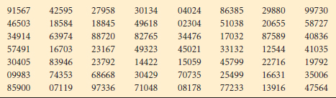

As an example, from the population frame of companies listed in [Table 7.2](http://proquestcombo.safaribooksonline.com.ezproxy.umuc.edu/9781118494769/ch007_sec004_html#tab7.2), we will use simple random sampling to select a sample of six companies. First, we number every member of the population. We select as many digits for each unit sampled as there are in the largest number in the population. For example, if a population has 2,000 members, we select four-digit numbers. Because the population in [Table 7.2](http://proquestcombo.safaribooksonline.com.ezproxy.umuc.edu/9781118494769/ch007_sec004_html#tab7.2) contains 30 members, only two digits need be selected for each number. The population is numbered from 01 to 30, as shown in [Table 7.3](http://proquestcombo.safaribooksonline.com.ezproxy.umuc.edu/9781118494769/ch007_sec004_html#tab7.3).

The object is to sample six companies, so six different two-digit numbers must be selected from the table of random numbers. Because this population contains only 30 companies, all numbers greater than 30 (31–99) must be ignored. If, for example, the number 67 is selected, we discard the number and continue the process until a value between 01 and 30 is obtained. If the same number occurs more than once, we proceed to another number. For ease of understanding, we start with the first pair of digits in [Table 7.1](http://proquestcombo.safaribooksonline.com.ezproxy.umuc.edu/9781118494769/ch007_sec004_html#tab7.1) and proceed across the first row until *n* = 6 different values between 01 and 30 are selected. If additional numbers are needed, we proceed across the second row, and so on. Often a researcher will start at some randomly selected location in the table and proceed in a predetermined direction to select numbers.

In the first row of digits in [Table 7.1](http://proquestcombo.safaribooksonline.com.ezproxy.umuc.edu/9781118494769/ch007_sec004_html#tab7.1), the first number is 91. This number is out of range so it is cast out. The next two digits are 56. Next is 74, followed by 25, which is the first usable number. From [Table 7.3](http://proquestcombo.safaribooksonline.com.ezproxy.umuc.edu/9781118494769/ch007_sec004_html#tab7.3), we see that 25 is the number associated with Occidental Petroleum, so Occidental Petroleum is the first company selected into the sample. The next number is 95, unusable, followed by 27, which is usable. Twenty-seven is the number for Procter & Gamble, so this company is selected. Continuing the process, we pass over the numbers 95 and 83. The next usable number is 01, which is the value for Alaska Airlines. Thirty-four is next, followed by 04 and 02, both of which are usable. These numbers are associated with Bank of America and Alcoa, respectively. Continuing along the first row, the next usable number is 29, which is associated with Sears. Because this selection is the sixth, the sample is complete. The following companies constitute the final sample.

**TABLE 7.2**   
A Population Frame of 30 Companies

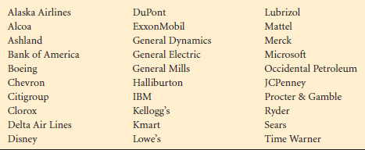

**TABLE 7.3**  
Numbered Population of 30 Companies

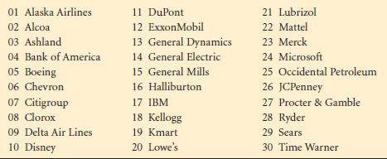

Alaska Airlines

Alcoa

Bank of America

Occidental Petroleum

Procter & Gamble

Sears

Simple random sampling is easier to perform on small than on large populations. The process of numbering all the members of the population and selecting items is cumbersome for large populations.

#### Stratified Random Sampling

A second type of random sampling is **stratified random sampling**, in which the population is divided into nonoverlapping subpopulations called strata. The researcher then extracts a random sample from each of the subpopulations (strata). The main reason for using stratified random sampling is that it has the potential for reducing sampling error. Sampling error occurs when, by chance, the sample does not represent the population. With stratified random sampling, the potential to match the sample closely to the population is greater than it is with simple random sampling because portions of the total sample are taken from different population subgroups. However, stratified random sampling is generally more costly than simple random sampling because each unit of the population must be assigned to a stratum before the random selection process begins.

Strata selection is usually based on available information. Such information may have been gleaned from previous censuses or surveys. Stratification benefits increase as the strata differ more. Internally, a stratum should be relatively homogeneous; externally, strata should contrast with each other. Stratification is often done by using demographic variables, such as sex, socioeconomic class, geographic region, religion, and ethnicity. For example, if a U.S. presidential election poll is to be conducted by a market research firm, what important variables should be stratified? The sex of the respondent might make a difference because a gender gap in voter preference has been noted in past elections; that is, men and women tended to vote differently in national elections. Geographic region also provides an important variable in national elections because voters are influenced by local cultural values that differ from region to region.

In FM radio markets, age of listener is an important determinant of the type of programming used by a station. [Figure 7.2](http://proquestcombo.safaribooksonline.com.ezproxy.umuc.edu/9781118494769/ch007_sec004_html#fig7.2) contains a stratification by age with three strata, based on the assumption that age makes a difference in programming preference. This stratification implies that listeners 20 to 30 years of age tend to prefer the same type of programming, which is different from that preferred by listeners 30 to 40 and 40 to 50 years of age. Within each age subgroup (stratum), *homogeneity* or alikeness is present; between each pair of subgroups a difference, or *heterogeneity*, is present.

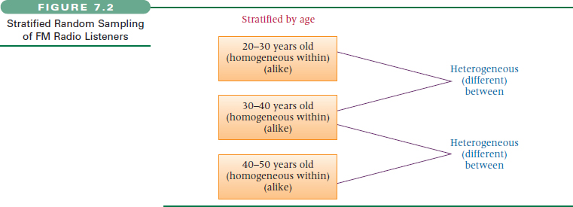

Stratified random sampling can be either proportionate or disproportionate. **Proportionate stratified random sampling** occurs *when the percentage of the sample**taken from each stratum is proportionate to the percentage that each stratum is within the whole population*. For example, suppose voters are being surveyed in Boston and the sample is being stratified by religion as Catholic, Protestant, Jewish, and others. If Boston's population is 90% Catholic and if a sample of 1,000 voters is taken, the sample would require inclusion of 900 Catholics to achieve proportionate stratification. Any other number of Catholics would be disproportionate stratification. The sample proportion of other religions would also have to follow population percentages. Or consider the city of El Paso, Texas, where the population is approximately 77% Hispanic. If a researcher is conducting a citywide poll in El Paso and if stratification is by ethnicity, a proportionate stratified random sample should contain 77% Hispanics. Hence, an ethnically proportionate stratified sample of 160 residents from El Paso's 660,000 residents should contain approximately 123 Hispanics. *Whenever the proportions of the strata in the sample**are different from the proportions of the strata in the population*, **disproportionate stratified random sampling** occurs.

#### Systematic Sampling

Systematic sampling is a third random sampling technique. Unlike stratified random sampling, systematic sampling is not done in an attempt to reduce sampling error. Rather, systematic sampling is used because of its convenience and relative ease of administration. With **systematic sampling,** *every kth**item is selected to produce a sample**of size n from a population of size N*. The value of *k*, sometimes called the sampling cycle, can be determined by the following formula. If *k* is not an integer value, the whole-number value should be used.

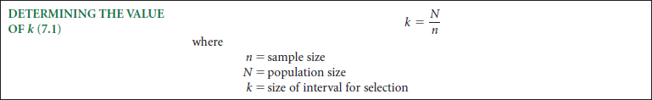

As an example of systematic sampling, a management information systems researcher wanted to sample the manufacturers in Texas. He had enough financial support to sample 1,000 companies (*n*). The *Directory of Texas Manufacturers* listed approximately 17,000 total manufacturers in Texas (*N*) in alphabetical order. The value of *k* was 17(17,000/1,000) and the researcher selected every 17th company in the directory for his sample.

Did the researcher begin with the first company listed or the 17th or one somewhere between? In selecting every *k*th value, a simple random number table should be used to select a value between 1 and *k* inclusive as a starting point. The second element for the sample is the starting point plus *k*. In the example, *k* = 17, so the researcher would have gone to a table of random numbers to determine a starting point between 1 and 17. Suppose he selected the number 5. He would have started with the 5th company, then selected the 22nd (5+17), and then the 39th, and so on.

Besides convenience, systematic sampling has other advantages. Because systematic sampling is evenly distributed across the frame, a knowledgeable person can easily determine whether a sampling plan has been followed in a study. However, a problem with systematic sampling can occur if the data are subject to any periodicity, and the sampling interval is in syncopation with it. In such a case, the sampling would be nonrandom. For example, if a list of 150 college students is actually a merged list of five classes with 30 students in each class and if each of the lists of the five classes has been ordered with the names of top students first and bottom students last, then systematic sampling of every 30th student could cause selection of all top students, all bottom students, or all mediocre students; that is, the original list is subject to a cyclical or periodic organization. Systematic sampling methodology is based on the assumption that the source of population elements is random.

#### Cluster (or Area) Sampling

Cluster (or area) sampling is a fourth type of random sampling. **Cluster (or area) sampling**involves dividing the population into non-overlapping areas, or clusters. However, in contrast to stratified random sampling where strata are homogeneous within, cluster sampling identifies clusters that tend to be internally heterogeneous. In theory, each cluster contains a wide variety of elements, and the cluster is a miniature, or microcosm, of the population. Examples of clusters are towns, companies, homes, colleges, areas of a city, and geographic regions. Often clusters are naturally occurring groups of the population and are already identified, such as states or Standard Metropolitan Statistical Areas. Although area sampling usually refers to clusters that are areas of the population, such as geographic regions and cities, the terms *cluster sampling*and *area sampling* are used interchangeably in this text.

After randomly selecting clusters from the population, the business researcher either selects all elements of the chosen clusters or randomly selects individual elements into the sample from the clusters. One example of business research that makes use of clustering is test marketing of new products. Often in test marketing, the United States is divided into clusters of test market cities, and individual consumers within the test market cities are surveyed. [Figure 7.3](http://proquestcombo.safaribooksonline.com.ezproxy.umuc.edu/9781118494769/ch007_sec004_html#fig7.3) shows some of the top U.S. cities that are used as clusters to test products. The Thinking Critically About Statistics in Business Today feature on test market cities elaborates more on the concept of test market cities and how they are selected.



Sometimes the clusters are too large, and a second set of clusters is taken from each original cluster. This technique is called **two-stage sampling**. For example, a researcher could divide the United States into clusters of cities. She could then divide the cities into clusters of blocks and randomly select individual houses from the block clusters. The first stage is selecting the test cities and the second stage is selecting the blocks.

Cluster or area sampling offers several advantages. Two of the foremost advantages are convenience and cost. Clusters are usually convenient to obtain, and the cost of sampling from the entire population is reduced because the scope of the study is reduced to the clusters. The cost per element is usually lower in cluster or area sampling than in stratified sampling because of lower element listing or locating costs. The time and cost of contacting elements of the population can be reduced, especially if travel is involved, because clustering reduces the distance to the sampled elements. In addition, administration of the sample survey can be simplified. Sometimes cluster or area sampling is the only feasible approach because the sampling frames of the individual elements of the population are unavailable, and therefore other random sampling techniques cannot be used.

**THINKING CRITICALLY ABOUT STATISTICS IN BUSINESS TODAY**

**Test Market Cities**

Companies that intend to introduce a new product across a country will often use test market cities to help determine how well the product will sell in the country and to gain insight into how to better market the product to consumers. Test market cities serve as a sample of the entire country, thereby reducing the cost of testing the product throughout the entire country and minimizing the time to do so. In the sense that test market cities are randomly selected areas from the country, such sampling could be viewed as a form of area or cluster sampling. However, there are other reasons (besides random selection) that test market cities are chosen, including demographics, familiarity, convenience, and psychographics. Sometimes a test market city is chosen because the company has used that city in a previous test and the product went on to be successful. Still, others are chosen because market researchers are comfortable there.

In cluster or area sampling, each area or cluster is ideally a miniature or microcosm of the population. This being the case for a test market city, a business researcher can gain the benefits of test marketing a product in an environment that closely resembles the population and, at the same time, realize cost and time savings benefits associated with sampling. According to Valerie Skala, Vice President of Analytic Product Management and Development at Information Resources, Inc., “To deliver accurate results, a test market must be representative of the United States in terms of sales development of the category and related products.” Josh Herman, Product Manager of Acxiom Corp, reports that companies in the United States have begun utilizing life-stage-based consumer segmentation to identify test market cities that most effectively represent the market makeup of consumers in the United States. One of these systems suggests that the 110 million U.S. households consist of 70 different life-stage segments, including “getting married,” “having children,” “raising kids,” “launching the kids out of the house,” “retiring,” etc. Since such life-stage changes greatly impact our consumer behavior, it is important that market researchers who are interested in test marketing products to the entire country select test market cities that most closely parallel the overall U.S. profile in life-stage segments.

According to one study, the Albany, New York, Metropolitan Statistical Area (MSA) is most closely correlated (with a correlation score of .91) in life-stage segments with the United States overall. Albany has almost the same proportion of consumers across the different life stages as one would find in the nation as a whole. Adopting such a test market city allows researchers to use multiple markets in their testing and, at the same time, have a consistent way to tie them together. [Figure 7.3](http://proquestcombo.safaribooksonline.com.ezproxy.umuc.edu/9781118494769/ch007_sec004_html#fig7.3) displays some of the top-rated test market cities in the United States.

**Things to Ponder**

**1.** Think about your home city. What characteristics of it would lend themselves to making your city an effective test market for the entire country? What characteristics would hinder the use of your city as a test market?

**2.** Select a product or service and suppose that it is going to be test marketed in a test market city. What characteristics (demographics) would a test market city have to have in order to conduct a successful market test?

*Source:* Adapted from “Marketing News: Albany, N.Y. Reflects True Test Market,” located at the Acxiom Corp's Web site: <http://www.acxiom.com/default.aspx?ID=2428&DisplayID=18>.

Cluster or area sampling also has several disadvantages. If the elements of a cluster are similar, cluster sampling may be statistically less efficient than simple random sampling. In an extreme case—when the elements of a cluster are the same—sampling from the cluster may be no better than sampling a single unit from the cluster. Moreover, the costs and problems of statistical analysis are greater with cluster or area sampling than with simple random sampling.

### Nonrandom Sampling

Sampling techniques used to select elements from the population by any mechanism that does not involve a random selection process are called **nonrandom sampling techniques**. Because chance is not used to select items from the samples, these techniques are non-probability techniques and are not desirable for use in gathering data to be analyzed by the methods of inferential statistics presented in this text. Sampling error cannot be determined objectively for these sampling techniques. Four nonrandom sampling techniques are presented here: convenenience sampling, judgment sampling, quota sampling, and snowball sampling.

#### Convenience Sampling

In convenience sampling, *elements for the sample are selected for the convenience of the researcher*. The researcher typically chooses elements that are readily available, nearby, or willing to participate. The sample tends to be less variable than the population because in many environments the extreme elements of the population are not readily available. The researcher will select more elements from the middle of the population. For example, a convenience sample of homes for door-to-door interviews might include houses where people are at home, houses with no dogs, houses near the street, first-floor apartments, and houses with friendly people. In contrast, a random sample would require the researcher to gather data only from houses and apartments that have been selected randomly, no matter how inconvenient or unfriendly the location. If a research firm is located in a mall, a convenience sample might be selected by interviewing only shoppers who pass the shop and look friendly.

#### Judgment Sampling

**Judgment sampling** occurs when *elements selected for the sample**are chosen by the judgment of the researcher*. Researchers often believe they can obtain a representative sample by using sound judgment, which will result in saving time and money. Sometimes ethical, professional researchers might believe they can select a more representative sample than the random process will provide. They might be right! However, some studies show that random sampling methods outperform judgment sampling in estimating the population mean even when the researcher who is administering the judgment sampling is trying to put together a representative sample. When sampling is done by judgment, calculating the probability that an element is going to be selected into the sample is not possible. The sampling error cannot be determined objectively because probabilities are based on *nonrandom* selection.

Other problems are associated with judgment sampling. The researcher tends to make errors of judgment in one direction. These systematic errors lead to what are called *biases*. The researcher also is unlikely to include extreme elements. Judgment sampling provides no objective method for determining whether one person's judgment is better than another's.

#### Quota Sampling

A third nonrandom sampling technique is **quota sampling**, which appears to be similar to stratified random sampling. Certain population subclasses, such as age group, gender, or geographic region, are used as strata. However, instead of randomly sampling from each stratum, the researcher uses a nonrandom sampling method to gather data from a stratum until the desired quota of samples is filled. Quotas are described by quota controls, which set the sizes of the samples to be obtained from the subgroups. Generally, a quota is based on the proportions of the subclasses in the population. In this case, the quota concept is similar to that of proportional stratified sampling.

Quotas are often filled by using available, recent, or applicable elements. [Table 7.4](http://proquestcombo.safaribooksonline.com.ezproxy.umuc.edu/9781118494769/ch007_sec004_html#tab7.4) shows how quota sampling might be used to fill quotas of consumers by age.

**TABLE 7.4**   
Using Quota Sampling to Fill Quotas of Consumers by Age

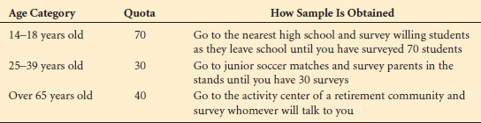

Note from studying [Table 7.4](http://proquestcombo.safaribooksonline.com.ezproxy.umuc.edu/9781118494769/ch007_sec004_html#tab7.4) that the researcher is using strata similar to stratified randomsampling. However, the quotas are filled in each case by using convenience sampling, and the result, while appearing to be scientific, is actually nonrandom sampling.

Quota sampling can be useful if no frame is available for the population. For example, suppose a researcher wants to stratify the population into owners of different types of cars but fails to find any lists of Toyota van owners. Through quota sampling, the researcher would proceed by interviewing all car owners and casting out non–Toyota van owners until the quota of Toyota van owners is filled.

Quota sampling is less expensive than most random sampling techniques because it essentially is a technique of convenience. However, cost may not be meaningful because the quality of nonrandom and random sampling techniques cannot be compared. Another advantage of quota sampling is the speed of data gathering. The researcher does not have to call back or send out a second questionnaire if he does not receive a response; he just moves on to the next element. Also, preparatory work for quota sampling is minimal.

The main problem with quota sampling is that, when all is said and done, it still is only a *nonrandom* sampling technique. Some researchers believe that if the quota is filled by *randomly* selecting elements and discarding those not from a stratum, quota sampling is essentially a version of stratified random sampling. However, most quota sampling is carried out by the researcher going where the quota can be filled quickly. The object is to gain the benefits of stratification without the high field costs of stratification. Ultimately, it remains a nonprobability sampling method.

#### Snowball Sampling

Another nonrandom sampling technique is **snowball sampling**, in *which survey**subjects are selected based on referral from other survey respondents*. The researcher identifies a person who fits the profile of subjects wanted for the study. The researcher then asks this person for the names and locations of others who would also fit the profile of subjects wanted for the study. Through these referrals, survey subjects can be identified cheaply and efficiently, which is particularly useful when survey subjects are difficult to locate. It is the main advantage of snowball sampling; its main disadvantage is that it is nonrandom.

### Sampling Error

**Sampling error** occurs *when the sample is not representative of the population*. When random sampling techniques are used to select elements for the sample, sampling error occurs by chance. Many times the statistic computed on the sample is not an accurate estimate of the population parameter because the sample was not representative of the population. This result is caused by sampling error. With random samples, sampling error can be computed and analyzed.

### Non-sampling Errors

*All errors other than sampling errors* are **non-sampling errors**. The many possible non-sampling errors include missing data, recording errors, input processing errors, and analysis errors. Other non-sampling errors result from the measurement instrument, such as errors of unclear definitions, defective questionnaires, and poorly conceived concepts. Improper definition of the frame is a non-sampling error. In many cases, finding a frame that perfectly fits the population is impossible. Insofar as it does not fit, a non-sampling error has been committed.

Response errors are also non-sampling errors. They occur when people do not know, will not say, or overstate. Virtually no statistical method is available to measure or control for non-sampling errors. The statistical techniques presented in this text are based on the assumption that none of these non-sampling errors were committed. The researcher must eliminate these errors through carefully planning and executing the research study.

## Estimating Sample Size

In most business research that uses sample statistics to infer about the population, being able to *estimate the size of sample**necessary to accomplish the purposes of the study* is important. The need for this **sample-size estimation** is the same for the large corporation investing tens of thousands of dollars in a massive study of consumer preference and for students undertaking a small case study and wanting to send questionnaires to local business people. In either case, such things as level of confidence, sampling error, and width of estimation interval are closely tied to sample size. If the large corporation is undertaking a market study, should it sample 40 people or 4,000 people? The question is an important one. In most cases, because of cost considerations, business researchers do not want to sample any more units or individuals than necessary.

### Sample Size When Estimating *μ*

In research studies when *μ* is being estimated, the size of sample can be determined by using the *z* formula for sample means and solving for *n*. Consider,



The difference between  and *μ* is the margin of **error of estimation** resulting from the sampling process. Let *E* = ( − *μ*) = the margin of error of estimation. Substituting *E* into the preceding formula yields



Solving for *n* yields a formula that can be used to determine sample size.



Sometimes in estimating sample size the population variance is known or can be determined from past studies. Other times, the population variance is unknown and must be estimated to determine the sample size. In such cases, it is acceptable to use the following estimate to represent *σ*.



Using formula (8.7), the business researcher can estimate the sample size needed to achieve the goals of the study before gathering data. For example, suppose a researcher wants to estimate the average monthly expenditure on bread by a family in Chicago. She wants to be 90% confident of her results. How much error is she willing to tolerate in the results? Suppose she wants the estimate to be within $1.00 of the actual figure (error) and the standard deviation of average monthly bread purchases is $4.00. What is the sample size estimation for this problem? The value of *z* for a 90% level of confidence is 1.645. Using formula (8.7) with *E* = $1.00, *σ* = $4.00, and *z* = 1.645 gives



That is, at least *n* = 43.3 must be sampled randomly to attain a 90% level of confidence and produce an error within $1.00 for a standard deviation of $4.00. Sampling 43.3 units is impossible, so this result should be rounded up to *n* = 44 units.

In this approach to estimating sample size, we view the error of the estimation as the amount of difference between the statistic (in this case, ) and the parameter (in this case, *μ*). The error could be in either direction; that is, the statistic could be over or under the parameter. Thus, the error, *E*, is actually ±*E* as we view it. So when a problem states that the researcher wants to be within $1.00 of the actual monthly family expenditure for bread, it means that the researcher is willing to allow a tolerance within ±$1.00 of the actual figure. Another name for this error is the **bounds** of the interval.

**DEMONSTRATION PROBLEM 8.7**

Suppose you want to estimate the average age of all Boeing 737-300 airplanes now in active domestic U.S. service. You want to be 95% confident, and you want your estimate to be within one year of the actual figure. The 737-300 was first placed in service about 24 years ago, but you believe that no active 737-300s in the U.S. domestic fleet are more than 20 years old. How large of a sample should you take?

#### Solution

Here, *E* = 1 year, the *z* value for 95% is 1.96, and *σ* is unknown, so it must be estimated by using *σ* ≈ (1/4) · (range). As the range of ages is 0 to 20 years, *σ* = (1/4)(20) = 5 Use formula (8.7).



Because you cannot sample 96.04 airplanes, the required sample size is 97. If you randomly sample 97 airplanes, you have an opportunity to estimate the average age of active 737-300s within one year and be 95% confident of the results.

**Note:** *Sample-size**estimates for the population mean where σ is unknown using the t distribution are not shown here. Because a sample size**must be known to determine the table value of t, which in turn is used to estimate the sample size, this procedure usually involves an iterative process*.

### Determining Sample Size When Estimating *p*

Determining the sample size required to estimate the population proportion, p, also is possible. The process begins with the z formula for sample proportions.



**TABLE 8.3**   
*p* · *q* for Various Selected Values of *p*

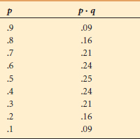

where *q* = 1 − *p*.

As various samples are taken from the population,  will rarely equal the population proportion, *p*, resulting in an error of estimation. The difference between  and *p* is the margin of error of estimation, so *E* =  − *p*.



Solving for *n* yields the formula for determining sample size.

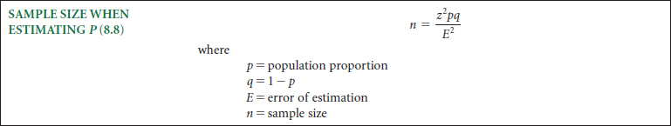

How can the value of *n* be determined prior to a study if the formula requires the value of *p*and the study is being done to estimate *p*? Although the actual value of *p* is not known prior to the study, similar studies might have generated a good approximation for *p*. If no previous value is available for use in estimating *p*, some possible *p* values, as shown in [Table 8.3](http://proquestcombo.safaribooksonline.com.ezproxy.umuc.edu/9781118494769/ch008_sec028_html#tab8.3), might be considered.

Note that, as *p* · *q* is in the numerator of the sample size formula, *p* = .5 will result in the largest sample sizes. Often *if p is unknown, researchers use .5 as an estimate of p* in Formula 8.8. This selection results in the largest sample size that could be determined from Formula 8.8 for a given *z* value and a given error value.

**DEMONSTRATION PROBLEM 8.8**

Hewitt Associates conducted a national survey to determine the extent to which employers are promoting health and fitness among their employees. One of the questions asked was, Does your company offer on-site exercise classes? Suppose it was estimated before the study that no more than 40% of the companies would answer Yes. How large a sample would Hewitt Associates have to take in estimating the population proportion to ensure a 98% confidence in the results and to be within .03 of the true population proportion?

#### Solution

The value of *E* for this problem is .03. Because it is estimated that no more than 40% of the companies would say Yes, *p* = .40 can be used. A 98% confidence interval results in a *z* value of 2.33. Inserting these values into formula (8.8) yields



Hewitt Associates would have to sample 1,448 companies to be 98% confident in the results and maintain an error of .03.

**DEMONSTRATION PROBLEM 8.9**

Suppose a researcher wants to estimate what proportion of refinery workers in the U.S. are contract workers. The researcher wants to be 99% confident of her results and be within .05 of the actual proportion. In addition, suppose that there have been no previous or similar studies to this, and therefore the researcher has no idea what is the actual population proportion. How large a sample size should be taken?

#### Solution

The value of *E* for this problem is .05. The value of *z* for a 99% confidence interval is 2.575. Because no estimate of the population proportion is available, the researcher will use *p* = .50 and *q* = .50. Placing these values into Formula 8.8:



The researcher would have to sample at least 664 workers to attain a 99% level of confidence and produce an error no bigger than .05 if the population proportion is approximately .50.

## Document Analysis (under the Requirements Elicitation in Practice section)

<https://learning.oreilly.com/library/view/System+Analysis+and+Design,+Fifth+Edition/9781118057629/11_chap03.html#chap03-sec014>

Project teams often use *document analysis* to understand the as-is system. Under ideal circumstances, the project team that developed the existing system will have produced documentation, which was then updated by all subsequent projects. In this case, the project team can start by reviewing the documentation and examining the system itself.

Unfortunately, most systems are not well documented, because project teams fail to document their projects along the way, and when the projects are over, there is no time to go back and document. Therefore, there may not be much technical documentation about the current system available, or it may not contain updated information about recent system changes. However, there are many helpful documents that do exist in the organization: paper reports, memorandums, policy manuals, user training manuals, organization charts, and forms. Problem reports filed by the system users can be another rich source of information about issues with the existing system.

But these documents (forms, reports, policy manuals, organization charts) only tell part of the story. They represent the *formal system* that the organization uses. Quite often, the “real,” or*informal system* differs from the formal one, and these differences, particularly large ones, give strong indications of what needs to be changed. For example, forms or reports that are never used likely should be eliminated. Likewise, boxes or questions on forms that are never filled in (or are used for other purposes) should be rethought. See [Figure 3-10](http://proquestcombo.safaribooksonline.com.ezproxy.umuc.edu/9781118057629/navPoint-41#fig3-10) for an example of how a document can be interpreted.

The most powerful indication that the system needs to be changed is when users create their own forms or add additional information to existing ones. Such changes clearly demonstrate the need for improvements to existing systems. Thus, it is useful to review both blank and completed forms to identify these deviations. Likewise, when users access multiple reports to satisfy their information needs, it is a clear sign that new information or new information formats are needed.

## Observation (under the Requirements Elicitation in Practice section)

<https://learning.oreilly.com/library/view/System+Analysis+and+Design,+Fifth+Edition/9781118057629/11_chap03.html#chap03-sec015>

*Observation*, the act of watching processes being performed, is a powerful tool to gain insight into the as-is system. Observation enables the analyst to see the reality of a situation, rather than listening to others describe it in interviews or JAD sessions.

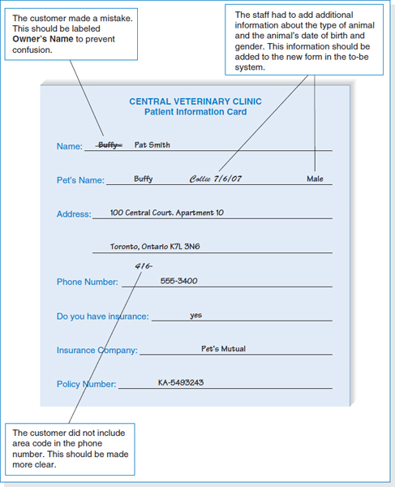

**FIGURE 3-10** Performing a Document Analysis

Several research studies have shown that many managers really do not remember how they work and how they allocate their time. (Quick, how many hours did you spend last week on each of your courses?) Observation is a good way to check the validity of information gathered from other sources such as interviews and questionnaires.

In many ways, the analyst becomes an anthropologist as he or she walks through the organization and observes the business system as it functions. The goal is to keep a low profile, to not interrupt those working, and to not influence those being observed. Nonetheless, it is important to understand that what analysts observe may not be the normal day-to-day routine because people tend to be extremely careful in their behavior when they are being watched.[10](http://proquestcombo.safaribooksonline.com.ezproxy.umuc.edu/9781118057629/navPoint-48#fn.0010_11_chap03)Even though normal practice may be to break formal organizational rules, the observer is unlikely to see this. (Remember how you drove the last time a police car followed you?) Thus, what you see may *not* be what you really want.

**CONCEPTS IN ACTION: 3-D PUBLIX CREDIT CARD FORMS**

|  |
| --- |
| **A**t my neighborhood Publix grocery store, the cashiers always handwrite the total amount of the charge on every credit card charge form, even though it is printed on the form. Why? Because the “back office” staff people who reconcile the cash in the cash drawers with the amount sold at the end of each shift find it hard to read the small print on the credit card forms. Writing in large print makes it easier for them to add the values up. However, cashiers sometimes make mistakes and write the wrong amount on the forms, which causes problems.  *Barbara Wixom*  **QUESTIONS**:   1. What does the credit card charge form indicate about the existing system? 2. How can you make improvements with a new system? |

Observation is often used to supplement interview information. The location of a person's office and its furnishings gives clues as to their power and influence in the organization, and such clues can be used to support or refute information given in an interview. For example, an analyst might become skeptical of someone who claims to use the existing computer system extensively if the computer is never turned on while the analyst visits. In most cases, observation will support the information that users provide in interviews. When it does not, it is an important signal that extra care must be taken in analyzing the business system.

## Selecting the Appropriate Techniques (under the Requirements Elicitation in Practice section)

<https://learning.oreilly.com/library/view/System+Analysis+and+Design,+Fifth+Edition/9781118057629/11_chap03.html#chap03-sec016>

Each of the requirements elicitation techniques just discussed has strengths and weaknesses. No one technique is always better than the others, and in practice most projects benefit from a combination of techniques. Thus, it is important to understand the strengths and weaknesses of each technique and when to use each. (See [Figure 3-11](http://proquestcombo.safaribooksonline.com.ezproxy.umuc.edu/9781118057629/navPoint-41#fig3-11).) One issue not discussed is that of the analysts' experience. In general, document analysis and observation require the least amount of training, while JAD sessions are the most challenging.

**Type of Information** The first characteristic is type of information. Some techniques are more suited for use at different stages of the analysis process, whether understanding the as-is system, identifying improvements, or developing the to-be system. Interviews and JAD are commonly used in all three stages. In contrast, document analysis and observation usually are most helpful for understanding the as-is system, although they occasionally provide information about improvements. Questionnaires are often used to gather information about the as-is system, as well as general information about improvements.

**YOUR TURN: 3-5 OBSERVATION PRACTICE**

|  |
| --- |
| **V**isit the library at your college or university and observe how the book check-out process occurs. First, watch several students checking books out, and then check one out yourself. Prepare a brief summary report of your observations.  When you return to class, share your observations with others. You may notice that not all the reports present the same information. Why? How would the information be different had you used the interview or JAD technique? |

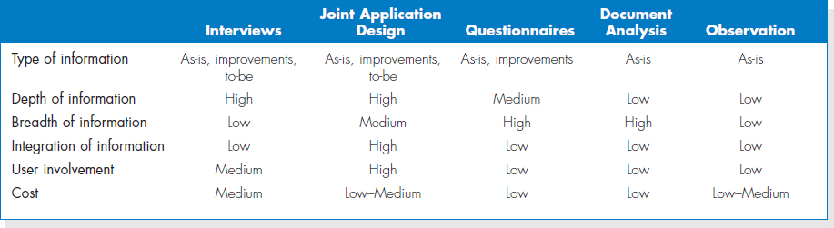

**FIGURE 3-11** Comparison of Requirements Elicitation Techniques

**Depth of Information** The depth of information refers to how rich and detailed the information is that the technique usually produces and the extent to which the technique is useful at obtaining not only facts and opinions, but also an understanding of *why* those facts and opinions exist. Interviews and JAD sessions are very useful at providing a good depth of rich and detailed information and helping the analyst to understand the reasons behind them. At the other extreme, document analysis and observation are useful for obtaining facts, but little beyond that. Questionnaires can provide a medium depth of information, soliciting both facts and opinions with little understanding of why.

**Breadth of Information** Breadth of information refers to the range of information and information sources that can be easily collected by that technique. Questionnaires and document analysis both are easily capable of soliciting a wide range of information from a large number of information sources. In contrast, interviews and observation require the analyst to visit each information source individually and, therefore, take more time. JAD sessions are in the middle because many information sources are brought together at the same time.

**Integration of Information** One of the most challenging aspects of requirements gathering is the integration of information from different sources. Simply put, different people can provide conflicting information. Combining this information and attempting to resolve differences in opinions or facts is usually very time consuming because it means contacting each information source in turn, explaining the discrepancy, and attempting to refine the information. In many cases, the individual wrongly perceives that the analyst is challenging his or her information, when in fact the source of conflict is another user in the organization. This can make the user defensive and make it hard to resolve the differences.

All techniques suffer integration problems to some degree, but JAD sessions are designed to improve integration because all information is integrated when it is collected, not afterward. If two users provide conflicting information, the conflict becomes immediately obvious, as does the source of the conflict. The immediate integration of information is the single most important benefit of JAD that distinguishes it from other techniques, and this is why most organizations use JAD for important projects.

**User Involvement** User involvement refers to the amount of time and energy the intended users of the new system must devote to the analysis process. It is generally agreed that, as users become more involved in the analysis process, the chance of success increases. However, user involvement can have a significant cost, and not all users are willing to contribute valuable time and energy. Questionnaires, document analysis, and observation place the least burden on users, while JAD sessions require the greatest effort.

**Cost** Cost is always an important consideration. In general, questionnaires, document analysis, and observation are low-cost techniques (although observation can be quite time consuming). The low cost does not imply that they are more or less effective than the other techniques. We regard interviews and JAD sessions as having moderate costs. In general, JAD sessions are much more expensive initially, because they require many users to be absent from their offices for significant periods, and they often involve highly paid consultants. However, JAD sessions significantly reduce the time spent in information integration and thus cost less in the long term.

## Requirements Analysis Strategies

<https://learning.oreilly.com/library/view/System+Analysis+and+Design,+Fifth+Edition/9781118057629/11_chap03.html#chap03-sec017>

The previous section discussed five essential techniques that analysts will use to interact with stakeholders in the system development project to elicit and define requirements. As we discussed earlier in the chapter, the analyst often must encourage the stakeholders to think critically about the needs for the new system and discover the true underlying requirements. In this section, we present several strategies that the analyst can employ with the stakeholders to accomplish this goal.

### Problem Analysis

The most straightforward (and probably the most commonly used) requirements analysis strategy is *problem analysis*. Problem analysis means asking the users and managers to identify problems with the as-is system and to describe how to solve them in the to-be system. Most users have a very good idea of the changes they would like to see, and most will be quite vocal about suggesting them. Most changes tend to solve problems rather than capitalize on opportunities, but this is possible, too. Improvements from problem analysis tend to be small and incremental (e.g., add a field to store the customer's cell phone number; provide a new report that currently does not exist).

This type of improvement often is very effective at improving a system's efficiency or ease of use. However, it often provides only minor improvements in business value—the new system is better than the old, but it may be hard to identify significant monetary benefits from the new system.

### Root Cause Analysis

The ideas produced by problem analysis tend to be *solutions* to problems. All solutions make assumptions about the nature of the problem, assumptions that may or may not be valid. In our experience, users (and most people in general) tend to jump quickly to solutions without fully considering the nature of the problem. Sometimes the solutions are appropriate, but many times they address a *symptom* of the problem, not the true problem or *root cause* itself.[11](http://proquestcombo.safaribooksonline.com.ezproxy.umuc.edu/9781118057629/navPoint-48#fn.0011_11_chap03)

For example, suppose that the users report that “inventory stock-outs happen frequently.” Inventory stock-outs are not good, of course, and one obvious way to reduce their occurrence is to increase the quantity of items kept in stock. This action incurs costs, however, so it is worthwhile to investigate the underlying cause of the frequent stock-outs instead of jumping to a quick-fix solution. The solutions that users propose (or systems that analysts consider) may address either symptoms or causes, but without careful analysis, it is difficult to tell which one. Finding out later that you've just spent millions of dollars and have not fixed the *true* underlying problem is a horrible feeling!

Root cause analysis focuses on problems first rather than solutions. The analyst starts by having the users generate a list of problems with the current system, then prioritizes the problems in order of importance. Starting with the most important, the users and/or analysts generate all possible root causes for the problem. As shown in [Figure 3-12](http://proquestcombo.safaribooksonline.com.ezproxy.umuc.edu/9781118057629/navPoint-42#fig3-12), the problem of “too frequent stock-outs” has several potential root causes (inaccurate on-hand counts; incorrect reorder points; lag in placing supplier orders). Each possible root cause is investigated and additional root causes are identified. As [Figure 3-12](http://proquestcombo.safaribooksonline.com.ezproxy.umuc.edu/9781118057629/navPoint-42#fig3-12) shows, it is sometimes useful to display the potential root causes in a tree-like hierarchy. Ultimately, the investigation process reveals the true root cause or causes of the problem, enabling the team to design the system to correct the problem with the right solution. The key point in root cause analysis is to always challenge the obvious and dig into the problem deeply enough that the true underlying cause(s) is revealed.

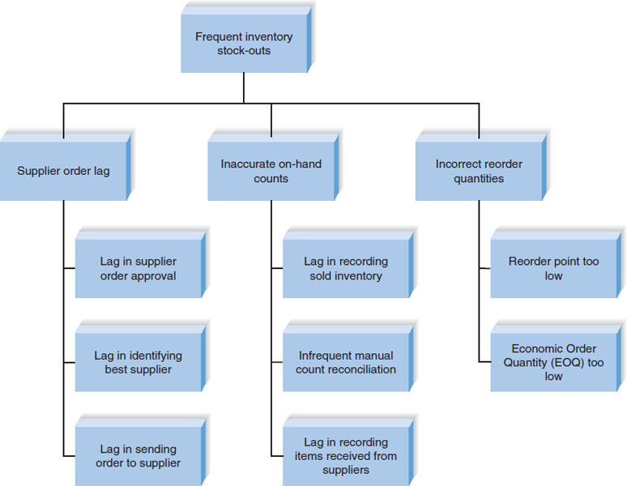

**FIGURE 3-12** Root Cause Analysis for Inventory Stock Outs

### Duration Analysis

*Duration analysis* requires a detailed examination of the amount of time it takes to perform each process in the current as-is system. The analysts begin by determining the total amount of time it takes, on average, to perform a set of business processes for a typical input. They then time each of the individual steps (or sub-processes) in the business process. The time to complete the basic steps are then totaled and compared with the total for the overall process. A significant difference between the two—and, in our experiences, the total time often can be 10 or even 100 times longer than the sum of the parts—indicates that this part of the process is badly in need of a major overhaul.

**CONCEPTS IN ACTION: 3-E SUCCESS FROM FAILURE**

|  |
| --- |
| **F**ew niches crashed more spectacularly during Web 1.0 than the pet sector. In 2000, over just nine months, [Pets.com](http://pets.com/) managed to raise a jaw-dropping $82.5 million in an IPO, air a $1.2 million Super Bowl ad starring its sock puppet mascot, land funding from [Amazon.com](http://amazon.com/) build a network of cavernous warehouses … and go out of business without making a penny in profit. When[Pets.com](http://pets.com/) rolled over and died in November 2000, it presaged scores of dot-com disasters to follow and slammed the door on online pet businesses, seemingly for good.  So when San Francisco Web designer Ted Rheingold co-founded [Dogster.com](http://dogster.com/" \t "_new)in January 2004 as a kind of canine version of Friendster, the news drew smirks from the few who bothered to notice. How could Dogster, a pet site cobbled together on weekends and launched on a shoestring budget, expect to succeed where lavishly funded pet sites had flamed out? The consensus on Dogster was unanimous: It would fail.  And indeed, it has failed. Over and over. But, alas, each knock has been a boost. Dogster has discovered ways to turn its mistakes into better features. With pretty much no promotion, Dogster (and sister site [Catster.com](http://catster.com/)) has evolved into a premier pet lover's social network. Membership exceeds 275,000; the site features 340,000 photos and profiles of dogs and cats, and a blue-chip advertising list that includes Disney, Holiday Inn, and Target. Dogster, come to find out, has a good profit sheet.  In many ways, the site is a prime example of how a Web deployment fails, but fails well by quick feature launch, seeing what works, and fixing things fast. According to Rheingold, “When we roll out a new feature, we know we're probably not going to get it right the first time.” Dogster and similar companies have discovered that continually reviewing user data —most importantly, the discouraging events—provides important direction for enhancements. Says Rheingold, “Instead of working on a feature for months trying to get it perfect, we'll work on something for two weeks and then spend two or three days listening to users and fine-tuning it.”  *Source*: “A Startup's Best Friend? Failure,” Tom McNichol, *Business 2.0*. San Francisco: March 2007, vol. 8, iss. 2, p. 39-41.  **QUESTIONS**:   1. Do you agree with Dogster's view, or should companies aim for “zero-defect” operations? Why or why not? What implications does this business model have for systems analysts? 2. Startup companies like Dogster are not the only companies that are implementing the “fail fast” strategy. Large companies like Google have used it and are still using it—in Google's case, with the implementation of the Google Toolbar. Cite another company that has used this strategy. Has it been successful? |

For example, suppose that the analysts are working on a home mortgage system and discover that, on average, it takes 30 days for the bank to approve a mortgage. They then look at each of the basic steps in the process (e.g., data entry, credit check, title search, appraisal, etc.) and find that the total amount of time actually spent on each mortgage is about 8 hours. This is a strong indication that the overall process is badly broken, because it takes 30 days to perform 1 day's work.

These problems likely occur because the process is badly fragmented. Many different people must perform different activities before the process is complete. In the mortgage example, the application probably sits on many peoples' desks for long periods of time before it is processed. Processes in which many different people work on small parts of the inputs are prime candidates for *process integration* or *parallelization*. Process integration means changing the fundamental process so that fewer people work on the input, which often requires changing the processes and retraining staff to perform a wider range of duties. Process parallelization means changing the process so that all the individual steps are performed at the same time. For example in the mortgage application example, there is probably no reason that the credit check cannot be performed at the same time as the appraisal and title check.

### Activity-Based Costing

*Activity-based costing* is a similar analysis that examines the cost of each major process or step in a business process rather than the time taken.[12](http://proquestcombo.safaribooksonline.com.ezproxy.umuc.edu/9781118057629/navPoint-48#fn.0012_11_chap03) The analysts identify the costs associated with each of the basic functional steps or processes, identify the most costly processes, and focus their improvement efforts on them.

Assigning costs is conceptually simple. You just examine the direct cost of labor and materials for each input. Materials costs are easily assigned in a manufacturing process, while labor costs are usually calculated on the basis of the amount of time spent on the input and the hourly cost of the staff. However, as you may recall from a managerial accounting course, there are indirect costs such as rent, depreciation, and so on that also can be included in activity costs.

### Informal Benchmarking

*Benchmarking* refers to studying how other organizations perform a business process in order to learn how your organization can do something better. Benchmarking helps the organization by introducing ideas that employees may never have considered, but that have the potential to add value.

*Informal benchmarking* is fairly common for “customer-facing” business processes (i.e., those processes that interact with the customer). With informal benchmarking, the managers and analysts think about other organizations, or visit them as customers to watch how the business process is performed. In many cases, the business studied may be a known leader in the industry or simply a related firm. For example, suppose that the team is developing a Web site for a car dealer. The project sponsor, key managers, and key team members would likely visit the Web sites of competitors, those of others in the car industry (e.g., manufacturers, accessories suppliers), and those of other industries that have won awards for their Web sites.

**CONCEPTS IN ACTION: 3-F A PROCESS IN NEED OF IMPROVEMENT**

|  |
| --- |
| **A** group of executives from a Fortune 500 company used duration analysis to discuss their procurement process. Using a huge wall of Velcro and a handful of placards, a facilitator proceeded to map out the company's process for procuring a $50 software upgrade. Having quantified the time it took to complete each step, she then assigned costs based on the salaries of the employees involved. The 15-minute exercise left the group stunned. Their procurement process had gotten so convoluted that it took 18 days, countless hours of paper-work and nearly $22,000 in people time to get the product ordered, received, and up and running on the requester's desktop.  *Source*: “For Good Measure,” *CIO* Magazine, March 1, 1999, by Debby Young. |

### Outcome Analysis

*Outcome analysis* focuses on understanding the fundamental outcomes that provide value to customers. While these outcomes sound as though they should be obvious, they often aren't. For example, suppose that you are an insurance company and one of your customers has just had a car accident. What is the fundamental outcome from the *customer* s perspective? Traditionally, insurance companies have answered this question by assuming that the customer wants to receive the insurance payment quickly. To the customer, however, the payment is only a *means*to the real outcome: a repaired car. The insurance company might benefit by extending its view of the business process past its traditional boundaries to include, not simply paying for repairs, but performing the repairs or contracting with an authorized body shop to do them.

With this approach, the system analysts encourage the managers and project sponsor to pretend that they are customers and to think carefully about what the organization's products and services enable the customers to do—and what they *could* enable the customer to do.

### Technology Analysis

Many major changes in business over the past decade have been enabled by new technologies.*Technology analysis* therefore starts by having the analysts and managers develop a list of important and interesting technologies. Then the group systematically identifies how each and every technology could be applied to the business process and identifies how the business would benefit.

For example, one useful technology might be the Internet. A manufacturer could develop an extranet application for its suppliers. Rather than ordering parts for its products, the manufacturer makes its production schedule available electronically to its suppliers, who ship the needed parts so that they arrive at the plant just in time. This saves significant costs because it eliminates the need for people to monitor the production schedule and issue purchase orders.

**CONCEPTS IN ACTION: 3-G “LIKE” YOUR LOCAL GOVERNMENT**

|  |
| --- |
| **M**unicipal, city, and county governments are seriously affected by the recent economic downturn and resulting budgetary pressure. Fewer employees mean it is harder to provide services in the same old way to citizens. Forward-thinking managers of governmental entities recognize that social media may be the wave of the future. Social media can allow citizens to be a part of the government services, not just a recipient of government services. Citizens can report issues such as potholes in roads or abandoned vehicles when they see them and government services can repair them while out in the field. Citizens are part of the process and get immediate satisfaction by helping to solve problems. |

**YOUR TURN: 3-6 IBM CREDIT**

|  |
| --- |
| **I**BM Credit was a wholly owned subsidiary of IBM responsible for financing mainframe computers sold by IBM. While some customers bought mainframes outright or obtained financing from other sources, financing computers provided significant additional profit.  When an IBM sales representative made a sale, he or she would immediately call IBM Credit to obtain a financing quote. The call was received by a credit officer who would record the information on a request form. The form would then be sent to the credit department to check the customer's credit status. This information would be recorded on the form, which was then sent to the business practices department, which would write a contract (sometimes reflecting changes requested by the customer). The form and the contract would then go to the pricing department, which used the credit information to establish an interest rate and record it on the form. The form and contract was then sent to the clerical group, where an administrator would prepare a cover letter quoting the interest rate and send the letter and contract via Federal Express to the customer.  The problem at IBM Credit was a major one. Getting a financing quote took anywhere from four to eight days (six days, on average), giving the customer time to rethink the order or find financing elsewhere. While the quote was being prepared, sales representatives would often call to find out where the quote was in the process, so that they could tell the customer when to expect it. However, no one at IBM Credit could answer the question, because the paper forms could be in any department and it was impossible to locate one without physically walking through the departments and going through the piles of forms on everyone's desk.  IBM Credit examined the process and changed it so that each credit request was logged into a computer system so that each department could record an application's status as soon as it was completed and sent it to the next department. In this way, sales representatives could call the credit office and quickly learn the status of each application. IBM used some sophisticated management science queuing theory analysis to balance workloads and staff across the different departments so that no applications would be overloaded. They also introduced performance standards for each department (e.g., the pricing decision had to be completed within one day after that department received an application).  However, process times got worse, even though each department was achieving almost 100 percent compliance on its performance goals. After some investigation, managers found that when people got busy, they conveniently found errors that forced them to return the credit request to the previous department for correction, thereby removing it from their time measurements.  **QUESTIONS**:  What techniques can you use to identify improvements? Choose one technique and apply it to this situation — what improvements did you identify?  *Source: Reengineering the Corporation*, New York: Harper Business, 1993, by M. Hammer and J. Champy. |

### Activity Elimination

*Activity elimination* is exactly what it sounds like. The analysts and managers work together to identify how the organization could eliminate each and every activity in the business process, how the function could operate without it, and what effects are likely to occur. Initially, managers are reluctant to conclude that processes can be eliminated, but this is a “force-fit” exercise in that they must eliminate each activity. In some cases the results are silly; nonetheless, participants must address each and every activity in the business process.

For example, in the home mortgage approval process discussed earlier, the managers and analysts would start by eliminating the first activity, entering the data into the mortgage company's computer. This leads to one of two obvious possibilities: (1) Eliminate the use of a computer system or (2) make someone else do the data entry (e.g., the customer, over the Web). They would then eliminate the next activity, the credit check. Silly, right? After all, making sure the applicant has good credit is critical in issuing a loan, isn't it? Not really. The real answer depends upon how many times the credit check identifies bad applications. If all or almost all applicants have good credit and are seldom turned down by a credit check, then the cost of the credit check may not be worth the benefit of the few bad loans it prevents. Eliminating it may actually result in lower costs, even with the cost of bad loans, unless the number of applicants with poor credit greatly increases.

### Comparing Analysis Strategies

Each of the requirements analysis strategies discussed here has its own purpose. No one technique is inherently better than the others. Remember that an organization will likely have a wide range of projects in its portfolio; the requirements analysis strategy should be chosen to fit the nature of the project. Problem analysis and root cause analysis tend to be most useful in situations with a narrow focus where efficiency gains are sought. Duration analysis and activity-based costing strategies help the team find the most “broken” business processes so that those processes can be redesigned and improved. Outcome analysis, technology analysis, and informal benchmarking help the team think “outside the box” and are very useful when the team is trying to create completely new ways of accomplishing the business processes.